

4ID3 - IoT Devices and Networks

Lab 3

Communicating Sensor Data over a LoRa Network

Adam Sokacz, Ishwar Singh, and Salman Bawa

Sponsored by [*Future Skills Center, Canada*](https://fsc-ccf.ca/) and[*McMaster W Booth SEPT*](https://www.eng.mcmaster.ca/sept)

Group Number:

Name, Student Number:

Name, Student Number:

Name, Student Number:

Submission Date:

# Objective

In this lab, sensor data will be read, encoded, and transmitted from a LoRa *Field Device* to a LoRa *Gateway Device*. The gateway will then forward that information to a Python *HTTP Server*, being run on a PC on the local WiFi network WiFi. This HTTP server will parse the sent data, publish to a corresponding *MQTT* path, update a *MongoDB database*, and return a response to the gateway device if the data transmission was successful.

Contents

Objective 2

Feedback 3

Additional Resources 3

Pre-Lab Questions 4

Post-Lab Questions 5

Exercise A Results: 7

Exercise B Results: 7

Exercise C Results: 7

Setting up the Workspace 8

Installing Python 15

Installing VSCode 16

Installing and Connecting to MongoDB 19

Wiring Diagram 23

ESP32 Libraries 25

Ping Pong 26

Device Network 35

Field Device 37

Gateway Device 41

HTTP Server 44

Repo Setup 45

Python Libraries 49

IoT Server Overview 50

Setting up the IoT Network 59

Integrating Everything Together 62

Exercise A 64

Exercise B 65

Exercise C 65

# Feedback

Q1 - What would you rate the difficulty of this lab?

*(1 = easy, 5 = difficult)*

|  |  |  |  |  |
| --- | --- | --- | --- | --- |
| **1** | **2** | **3** | **4** | **5** |

Comments about the difficulty of the lab:

Q2 - Did you have enough time to complete the lab within the designated lab time?

|  |  |
| --- | --- |
| **YES** | **NO** |

Q3 - How easy were the lab instructions to understand?

*(1 = easy, 5 = unclear)*

|  |  |  |  |  |
| --- | --- | --- | --- | --- |
| **1** | **2** | **3** | **4** | **5** |

List any unclear steps:

Q4 - Could you see yourself using the skills learned in this lab to tackle future engineering challenges?

*(1 = no, 5 = yes)*

|  |  |  |  |  |
| --- | --- | --- | --- | --- |
| **1** | **2** | **3** | **4** | **5** |

# Additional Resources

**Lab GitHub Repo** ( <https://github.com/sokacza/4ID3> )

Python Webservers ( <https://youtu.be/DeFST8tvtuI> )

MongoDB Databases with PyMongo ( <https://youtu.be/rE_bJl2GAY8> )

NodeRED Fundamentals Tutorial ( <https://youtu.be/3AR432bguOY> )

ESP32 Overview ( <https://youtu.be/UuxBfKA3U5M> )

# Pre-Lab Questions

Q1 - In your own words, what is the difference between LoRa technology and LoRaWAN? What layer of the OSI model do each reside in?

(Suggested: 3 sentences, 1.5 points)

Q2 - What is point-to-point communication? What role does a transceiver play? How does it differ from more sophisticated network topologies?

(Suggested: 3 sentences, 1.5 points)

Q3 - What is an API request in web development? What is the difference between a GET and POST request to an API?

<https://youtu.be/ByGJQzlzxQg>

<https://www.youtube.com/watch?v=UObINRj2EGY>

(Suggested: Short paragraph, 3 points)

Q4 - A server URL is made up of the following components:

http://127.0.0.1:3000/data -> **PROTOCOL://IP_ADDRESS:PORT/PATH**

The role of each component is the following:

|  |  |
| --- | --- |
| **Protocol** | How the data is being transmitted |
| **IP Address** | The PC/Server being communicated with |
| **Port** | The resource on the server being accessed |
| **Path** | The function of that resource being used |

If an API exists at *http://192.168.2.10:3000/send_data_to_mqtt* that expects the following data:

{

“GroupA”: {

“DeviceA”: {

“Temperature”: 20,

“Humidity”: 43

} } }

But you submit **incorrectly formatted** data in your API request, what error codes might you expect to receive?

<https://www.baeldung.com/rest-api-error-handling-best-practices>

(Suggested: List, 2 points)

# Post-Lab Questions

Q1 – Using software like **PowerPoint** or **Draw.IO**, create a diagram to represent the nodes in part B of this IoT network and **label the data** being exchanged between each node.

(Suggested: Diagram, 5 points)

Q2 - If a LoRa device is configured for use in North America, can it be legally used in Europe? Briefly describe how LoRa frequency bands are regulated differently in these two locations.

<https://www.thethingsnetwork.org/docs/lorawan/>

(Suggested: A few sentences, 2 points)

Q3 - How does the LoRa Spreading Factor and Transceiver Power affect transmission range? What spreading factor would you suggest when transmitting over vast distances?

<https://www.thethingsnetwork.org/docs/lorawan/>

(Suggested: Short paragraph, 3 points)

Q4 – What is signal modulation? Using a sketch, compare and contrast AM vs FM modulation. Using a sketch, compare and contrast ASK & FSK to AM & PM modulation.

<https://youtu.be/I0jdIvwkiDI>

<https://youtu.be/qGwUOvErR8Q>

(Suggested: 2 sketches + 2 sentences, 5 points)

Q5 – What is a CHIRP in LoRa communication? Use a sketch in your explanation. How does CHIRP Spread Spectrum compare with other modulation techniques?

<https://youtu.be/dxYY097QNs0>

(Suggested: 1 sketch + short paragraph, 3 points)

Q5 - When communicating to a transceiver over serial communication, a TX pin from the microcontroller must be wired to the transceiver RX, and vice versa. Why is this the case? If the TX pin on the microcontroller was faulty, would it still be able to receive data from the transceiver?

(Suggested: 3 sentences, 2 points)

Q6 - In part B, an HTTP server was used to implement an API for converting sensor data to an MQTT message and a different API for inserting the data into a database. What Arduino library was used to make an API request to the HTTP server? What function was used to issue that request?

(Suggested: 2 sentences, 2 points)

Q7 - In this lab, the HTTP server is used to:

1. Reroute data to an MQTT broker
2. Insert data as documents in a MongoDB database
3. Display data to the user as an HTML web page

Describe how servers might be advantageous to use in larger IoT networks and compare the processing power and software capabilities of a PC running a server to a resource restricted microcontroller.

(Suggested: 2 sentences, 1 point)

Q8 - Write a brief LinkedIn post about 4 key learning takeaways from this lab.

(Suggested: Short paragraph, 4 points)

# Exercise A Results:

# Exercise B Results:

# Exercise C Results:

# Setting up the Workspace

Each lab, we will be creating a new folder in the local git repository that was created in the provided pre-lab to store and document technologies that you have worked on.

Navigate to your local git repository for this course.



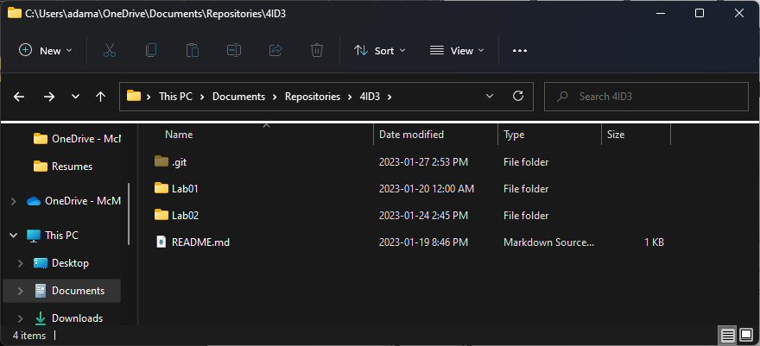

Create a new folder named **Lab02**. Navigate inside this folder.

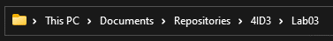

Create a new text file in the folder.

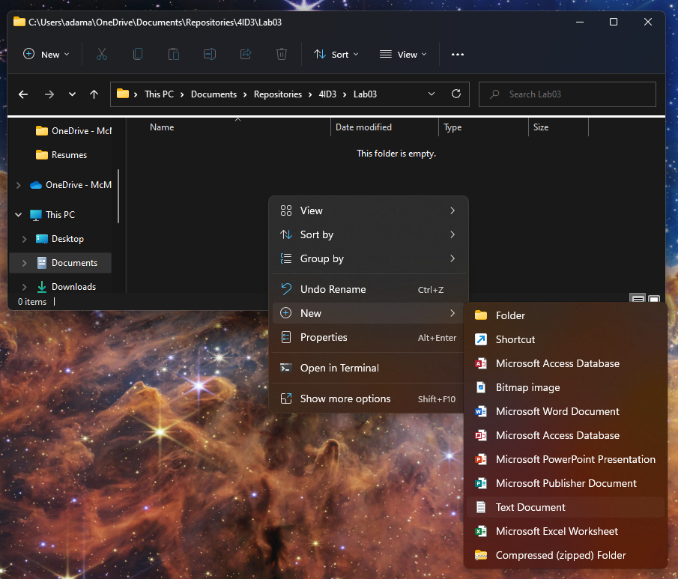

Press **File > Save as.**

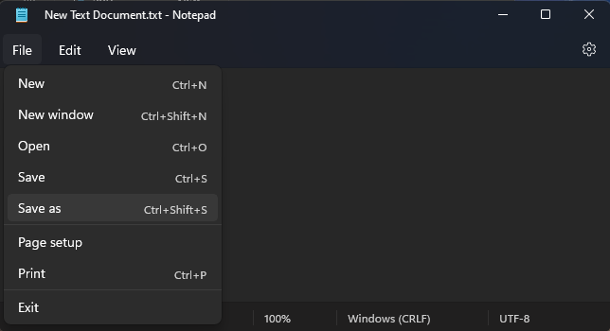

Save it as **Lab02.md**. Ensure that the **Save as type** is set to **All files (*.*)**.

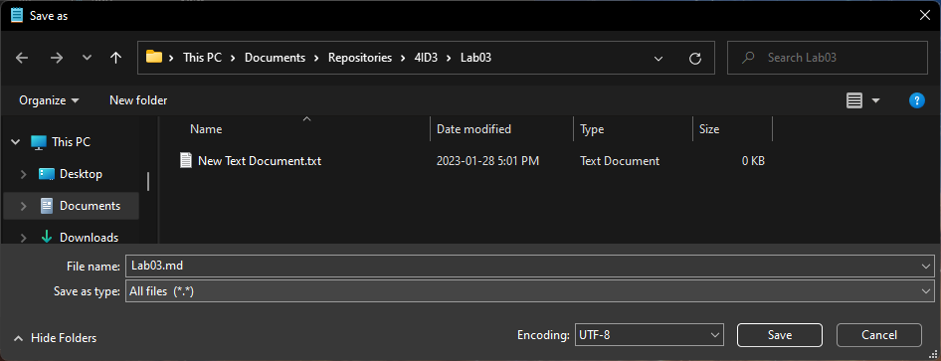

Now, you should have two files, a **text file** and a **markdown file**. Delete the text file.

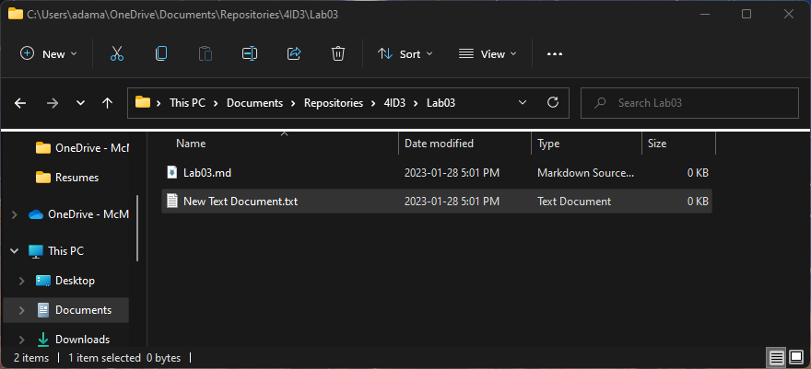

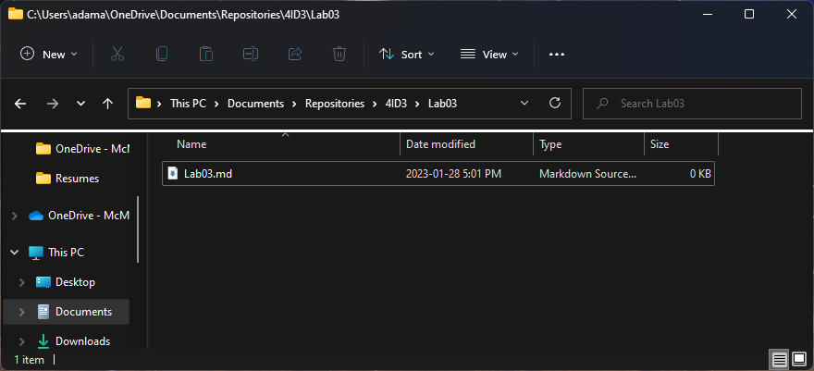

To open the markdown file, **right-click** and select **Open with**. Choose **Notepad**.

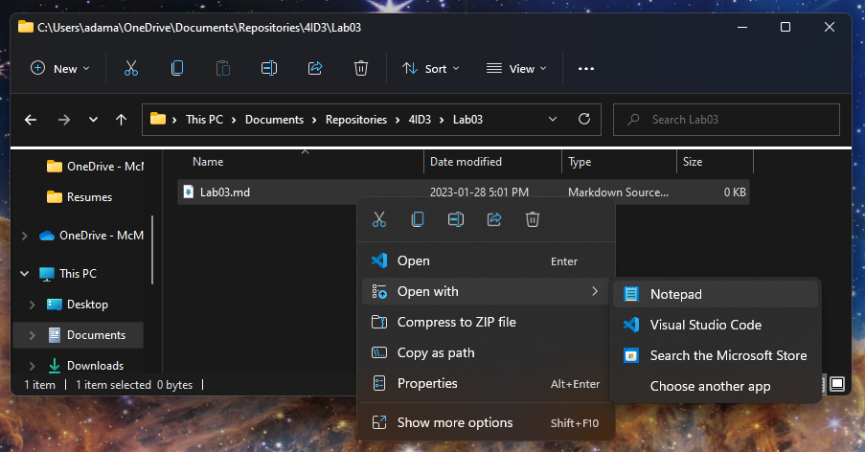

Writing markdown documents to explain your code is very similar to HTML. A reference guide can be found here:

<https://docs.github.com/en/get-started/writing-on-github/getting-started-with-writing-and-formatting-on-github/basic-writing-and-formatting-syntax>

Write the following text in the markdown file and save it.

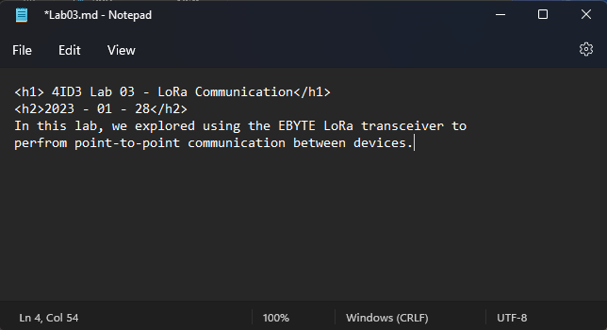

*<h1> 4ID3 Lab 03 - LoRa Communication</h1>*

*<h2>2023 - 01 - 28</h2>*

*In this lab, we explored using the EBYTE LoRa transceiver to*

*perform point-to-point communication between devices.*

**Save** the file.

Navigate to the **root folder** (*4ID3/, root main highest-level folder*) of your local repository.

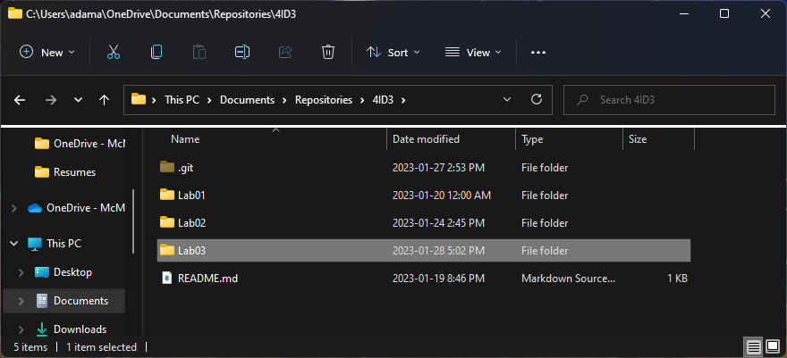

**Right-click** in the root folder of your local repository and launch **git bash**.

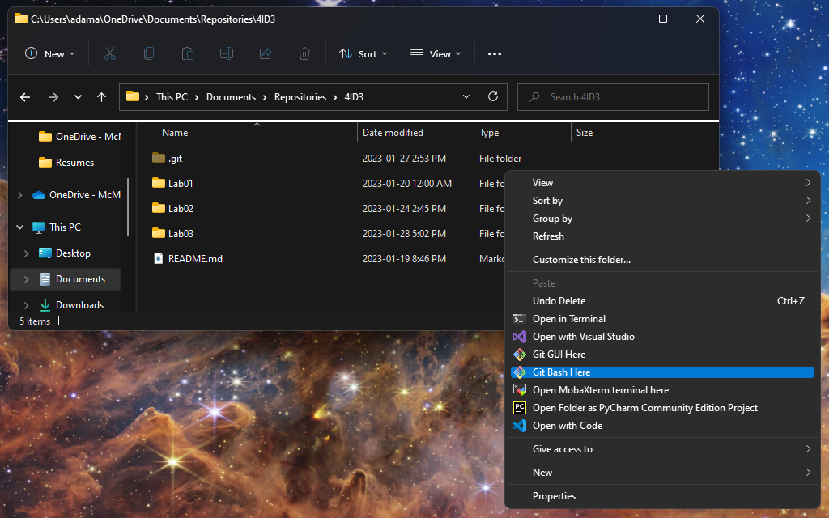

First, we need to add all the changes to the index that will be synced with GitHub. This will be done with the git add command.

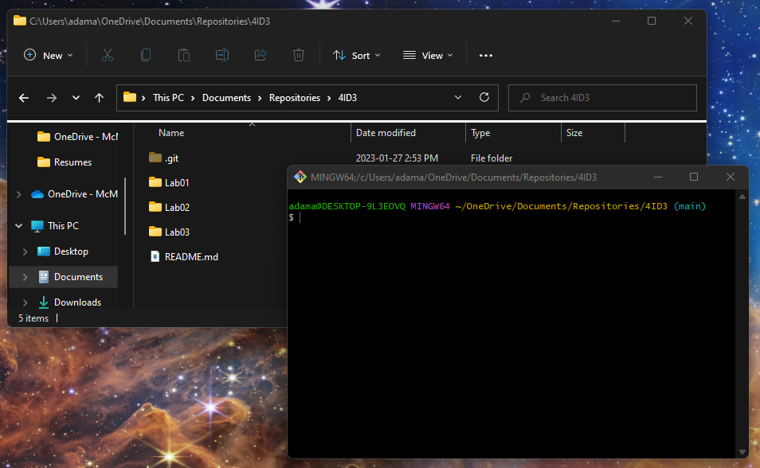

*git add .*

The period ‘.’ Is used as a shorthand for selecting all changes.

Next, when we are happy with the changes we chose to upload, we can use the commit command to package them to be synced.

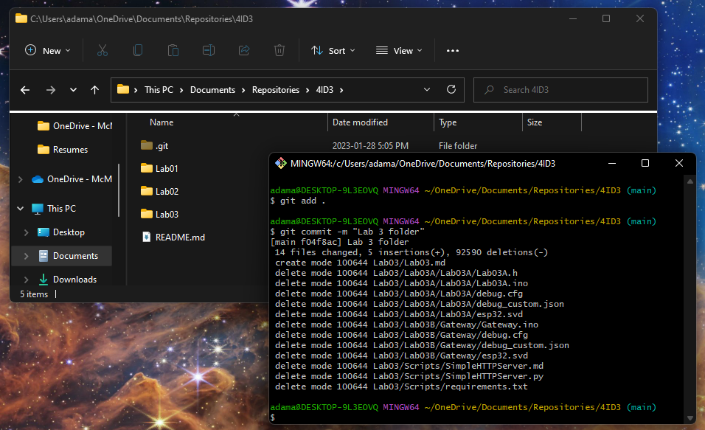

*git commit -m “Lab 3 folder”*

The ‘-m’ flag stands for message, and it adds a message that explains what changes were made.

Lastly, to sync your local git repository with GitHub, use the git push command.

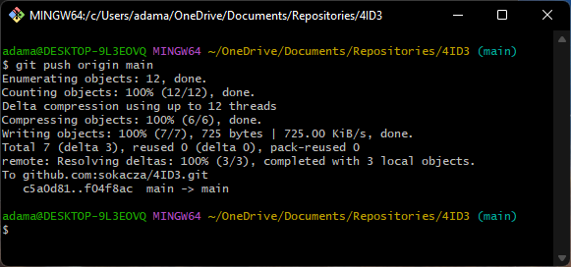

*git push origin main*

Now, log into GitHub and verify that the changes have been made.

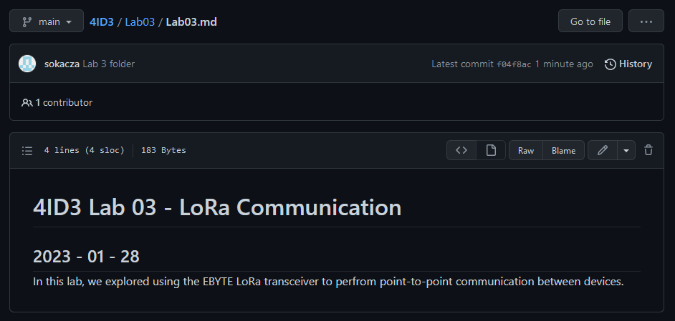

Now, if you are collaborating and wish to sync your local git repo with the remote GitHub repo, use the git pull command. In this case, we see that our local git repo is already up-to-date.

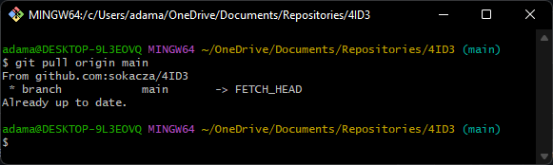

# Installing Python

Navigate to the following website and install the latest version of Python 3.

<https://www.python.org/downloads/>

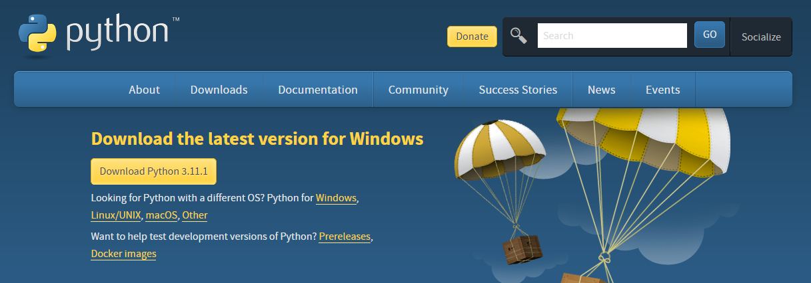

Install using the default options. If there is a checkbox to **Add to Path**, please **check this checkbox**.

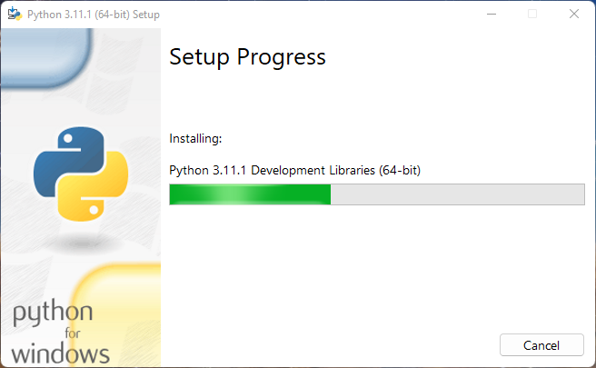

**MAKE SURE THAT YOU CHECK OFF ‘ADD TO PATH’ AND ‘DISABLE PATH LENGTH LIMIT’**

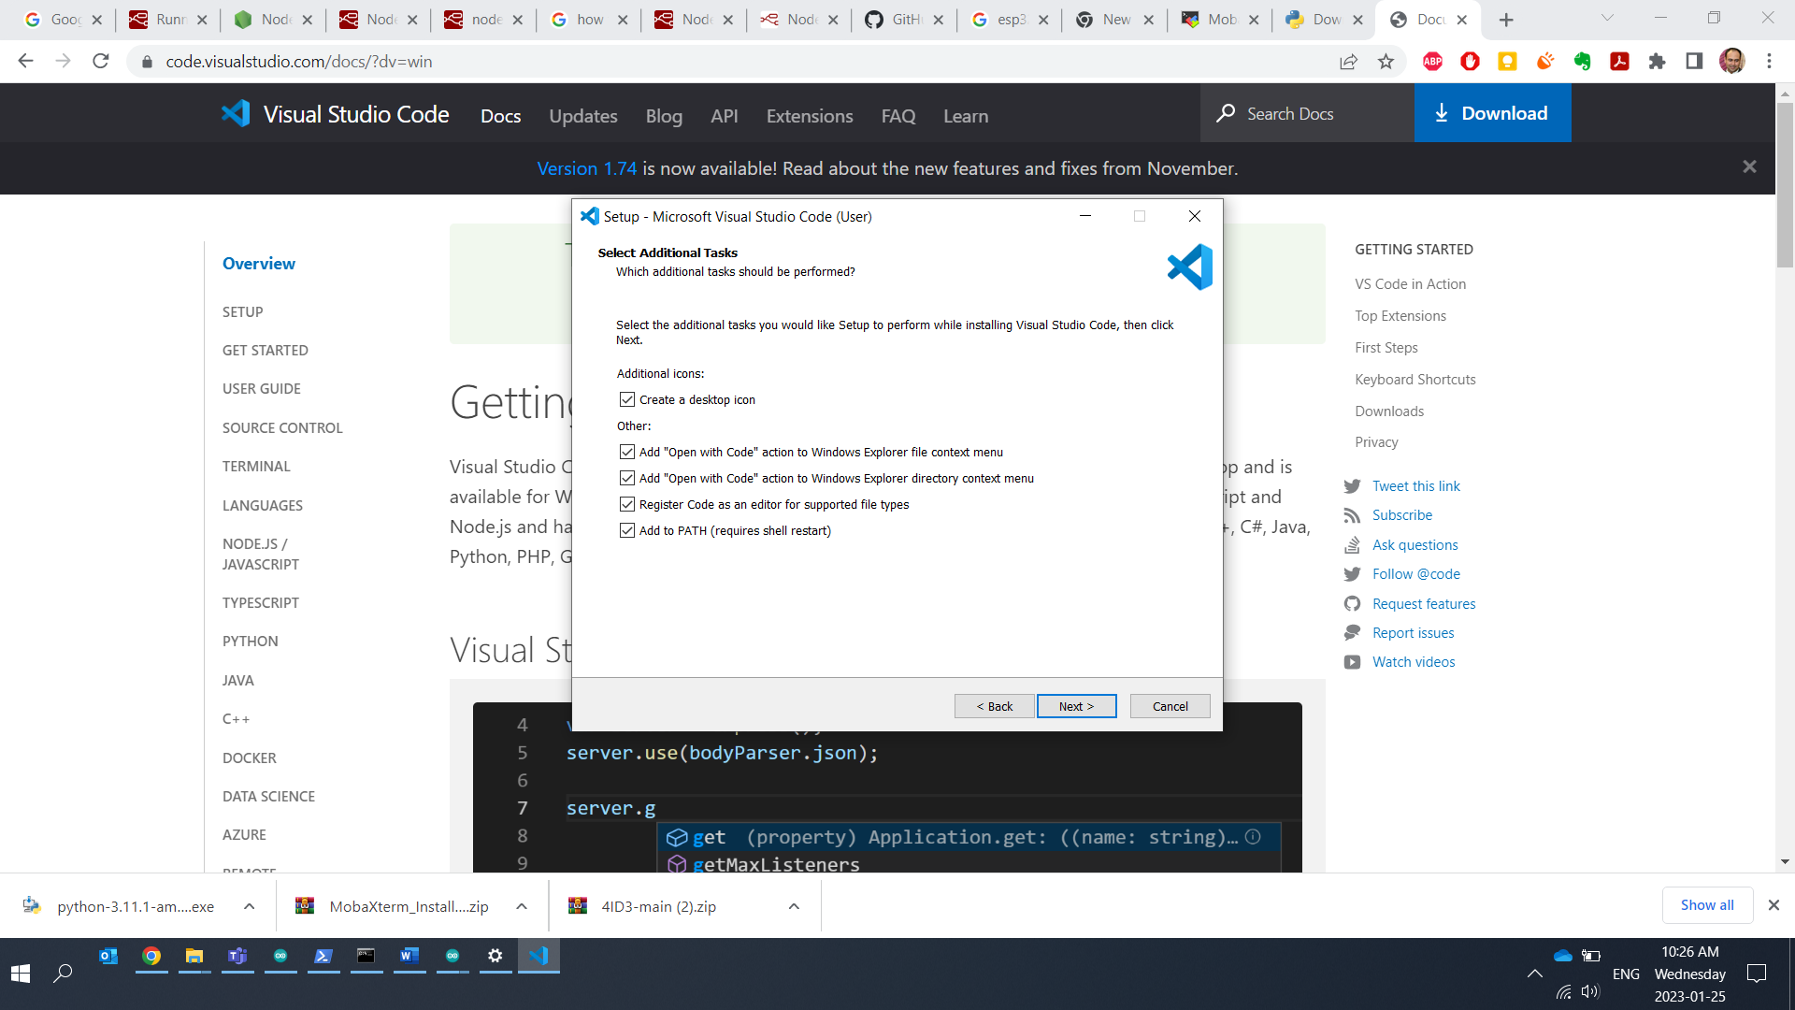

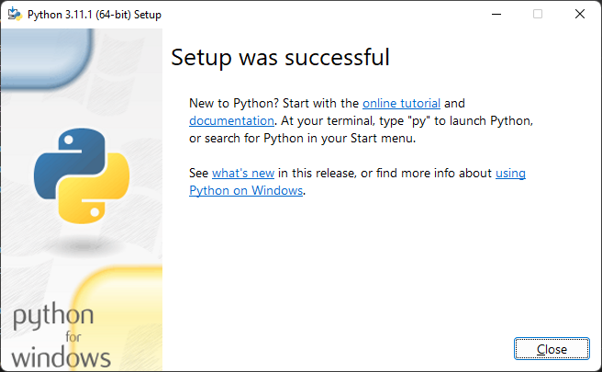

Once Python is installed, please **restart** your computer.

## Installing VSCode

Navigate to the following URL:

<https://code.visualstudio.com/download>

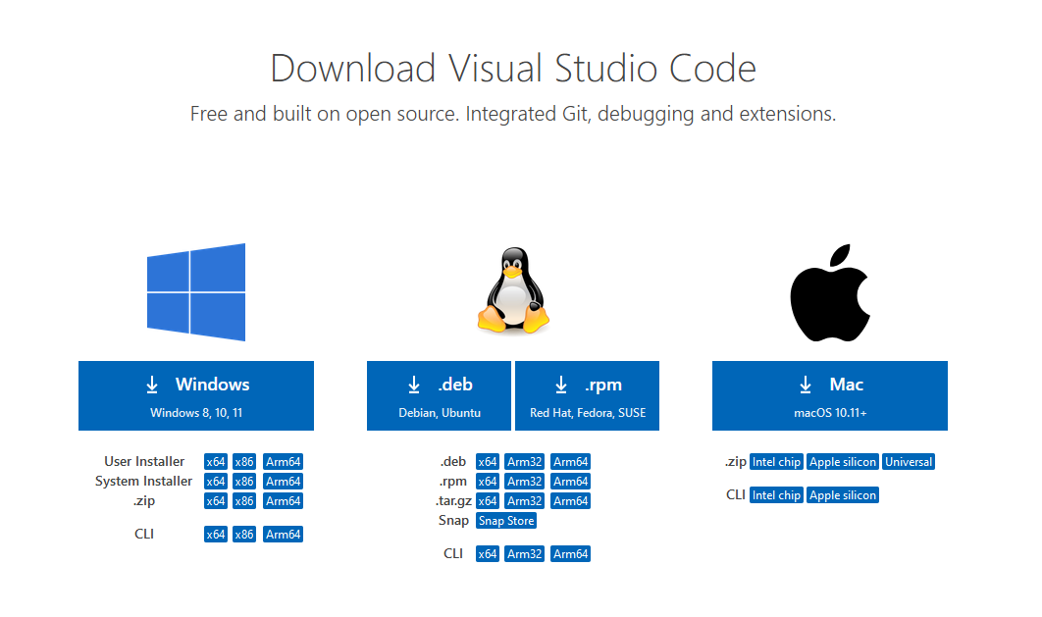

Run the installer using the **default install options**.

Once installed launch **VSCode**.

Open the **Extensions** tab using the ribbon on the left-side.

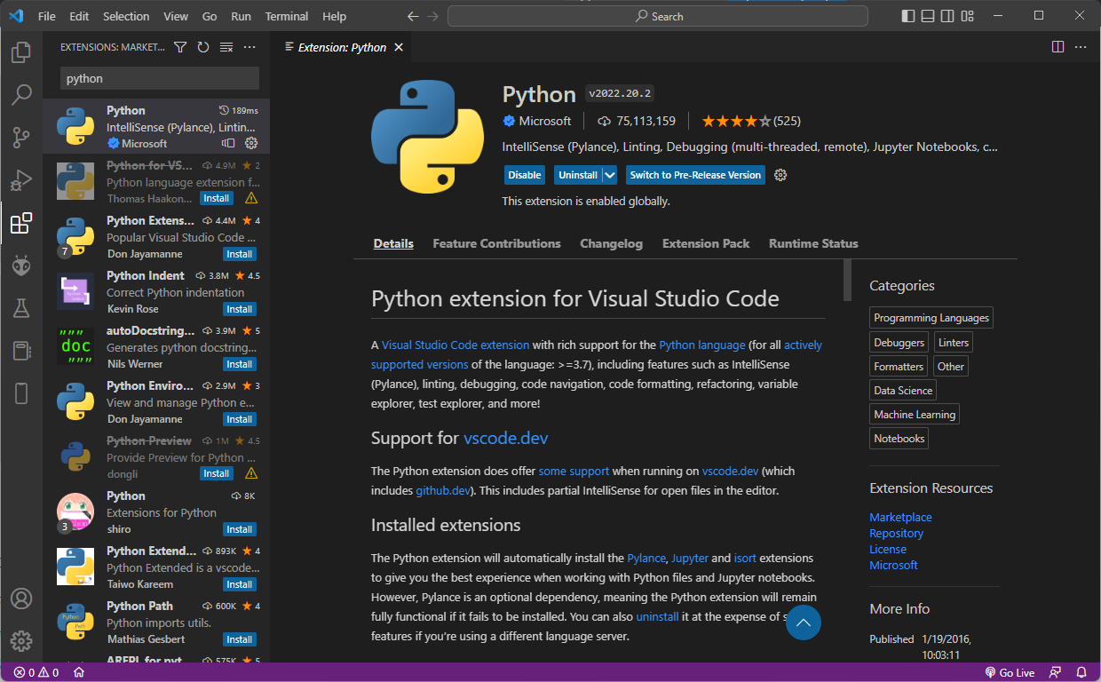

Search for **Python** and **Install** the one provided by **Microsoft**.

Within VSCode, do **File > Open Folder**.

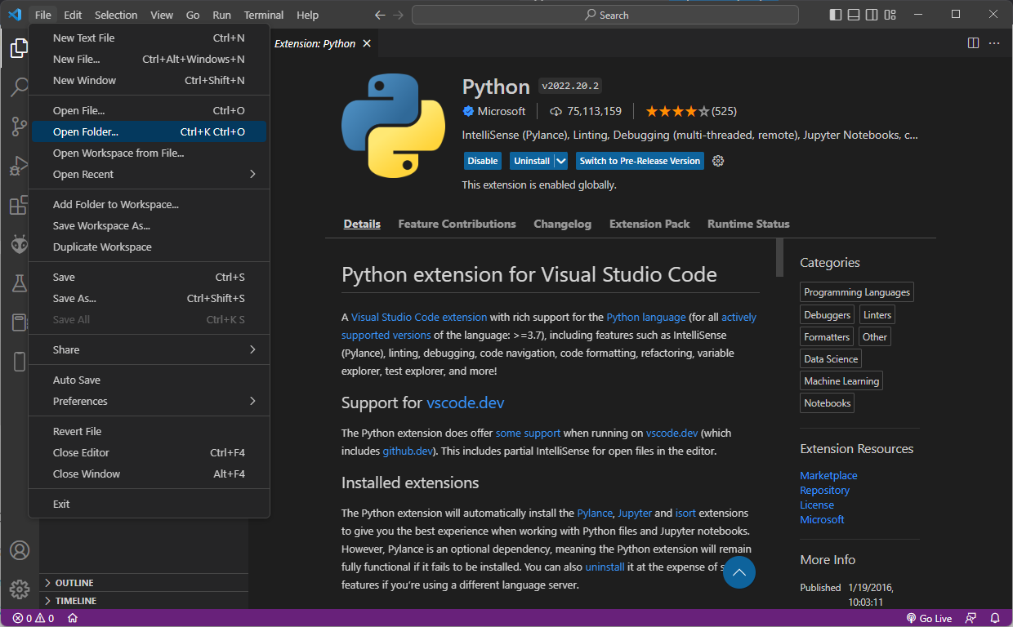

Open your local repository.

# Installing and Connecting to MongoDB

Navigate to the following URL and download **MongoDB Community**.

<https://www.mongodb.com/try/download/community-kubernetes-operator>

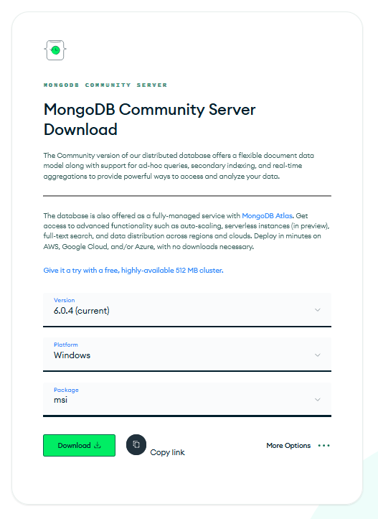

Run the installer using default settings. It will say **This may contain malicious software**. Ignore this warning, this software is very reputable, the packaging format is just out-of-date.

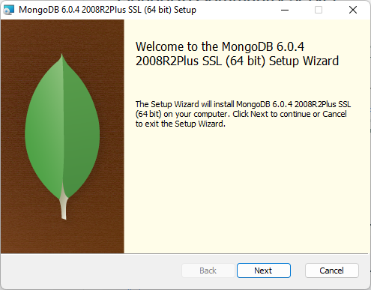

Perform a **Complete** installation.

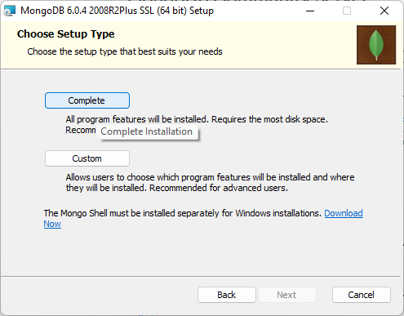

Leave **Service Configuration** as default.

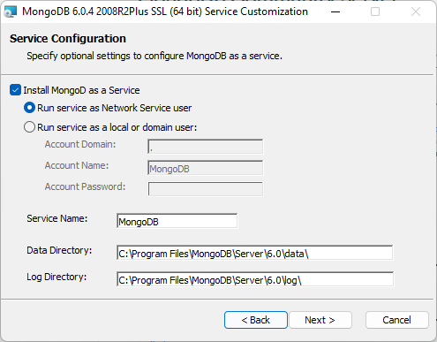

Ensure that **Install MongoDB Compass** is **checked**.

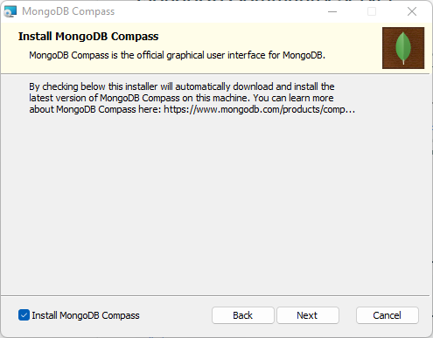

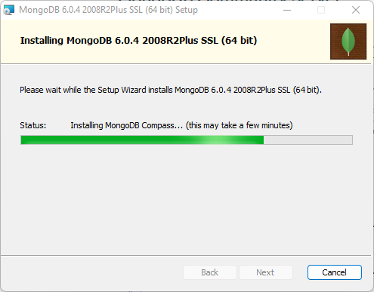

Launch **MongoDB Compass**.

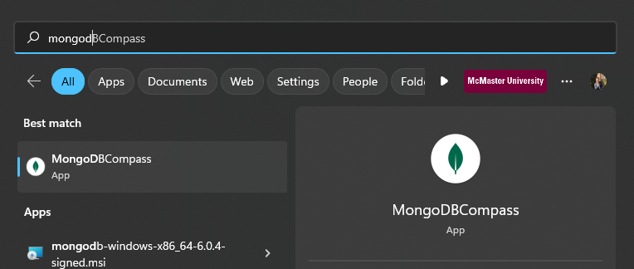

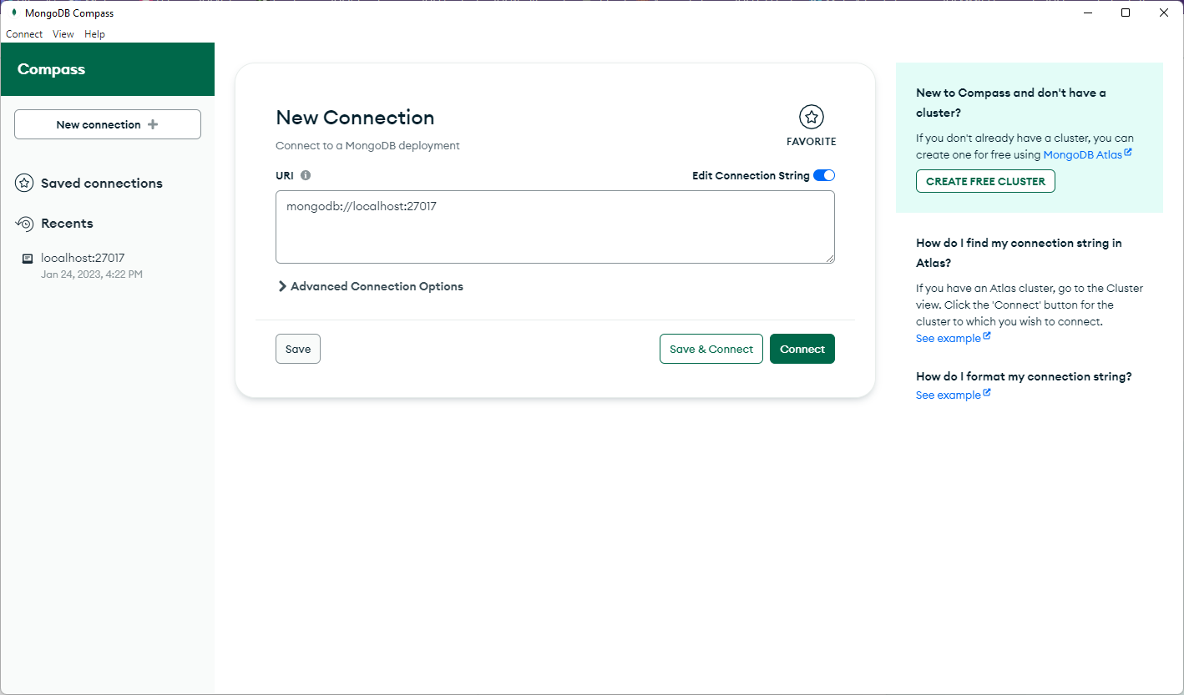

Press **Connect**.

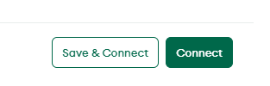

# Wiring Diagram

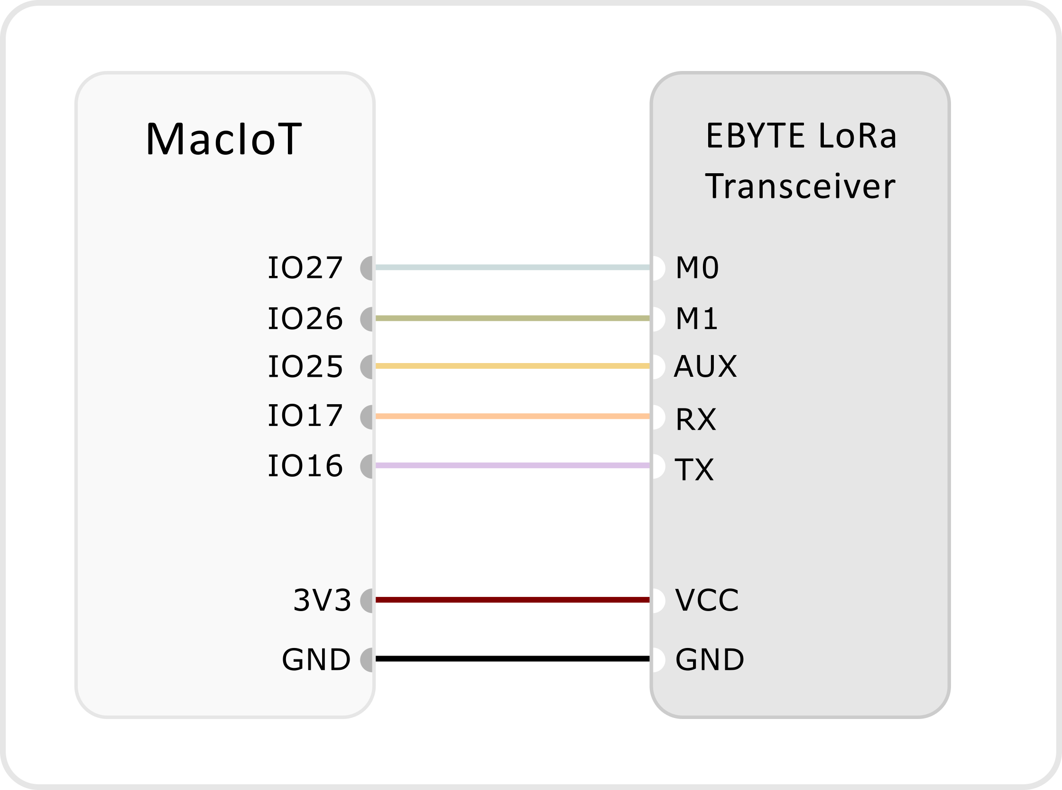

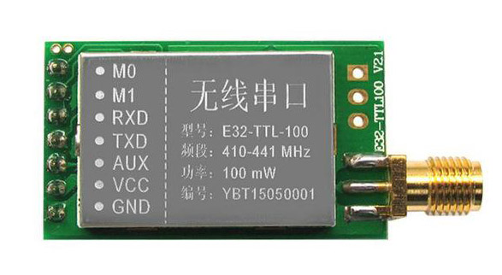

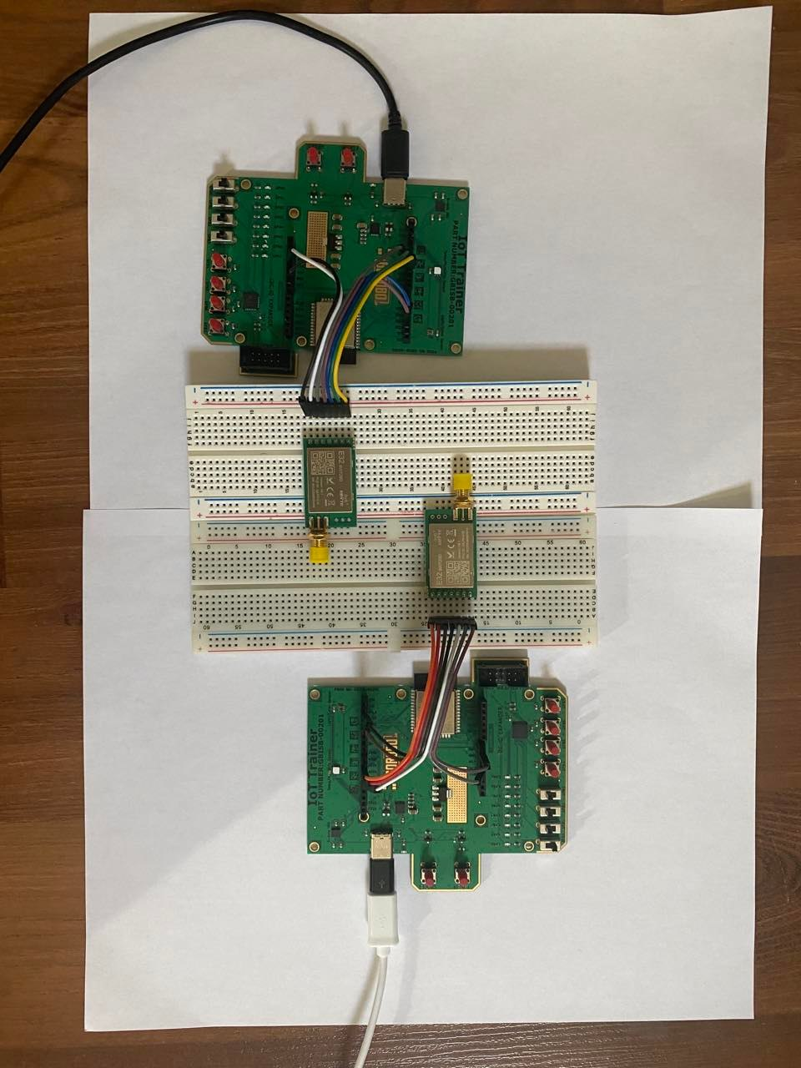

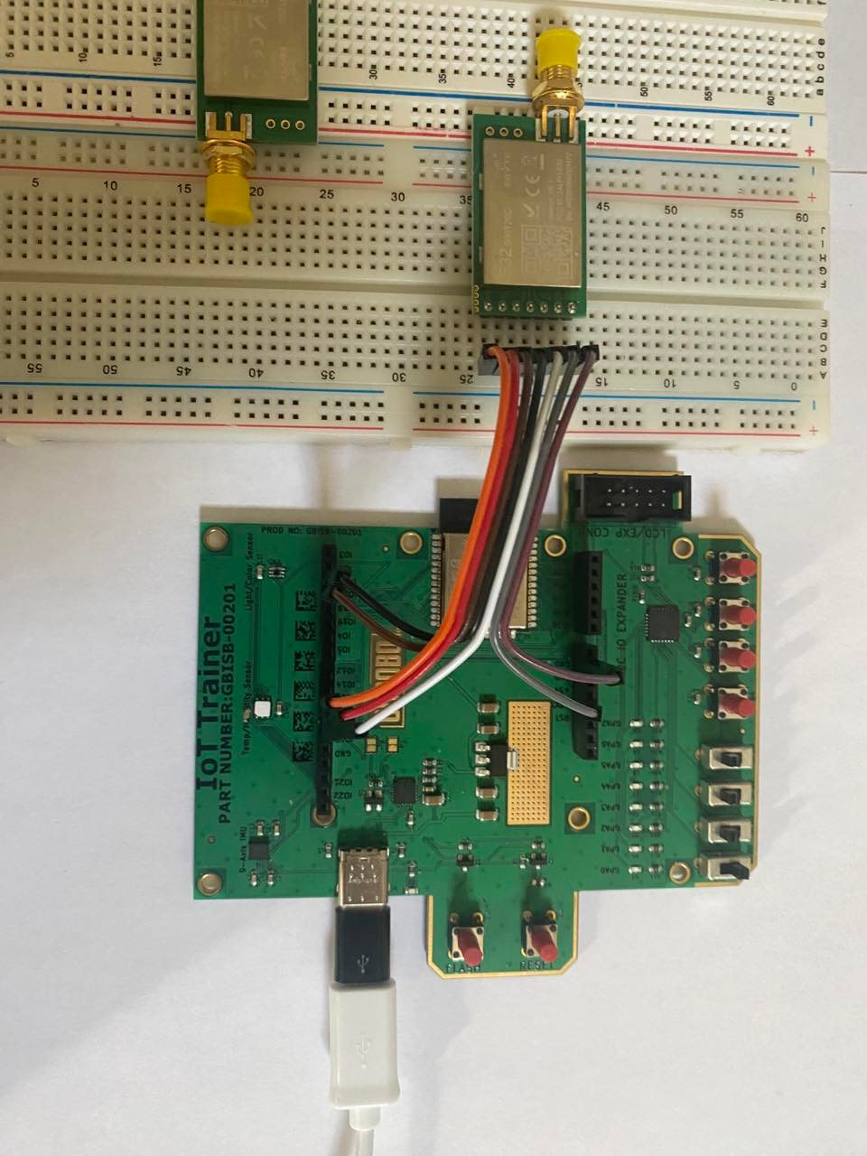

# ESP32 Libraries

Navigate to the following repo and download the library as a **zip** file.

<https://github.com/KrisKasprzak/EBYTE>

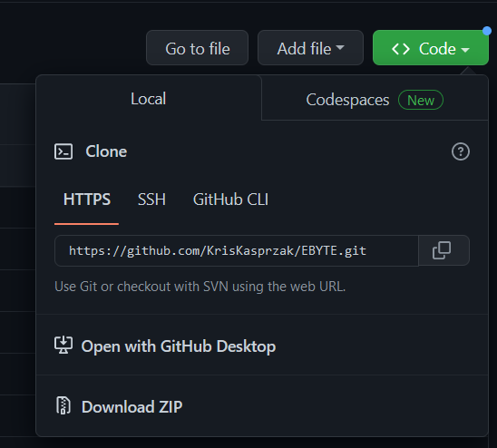

Install it in the Arduino IDE by navigating to **Sketch > Include Library > Add .ZIP Library**.

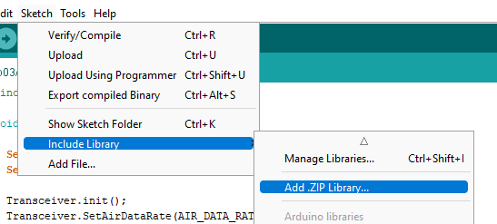

# Ping Pong

The goal of this experiment is to observer point-to-point communication between two LoRa transceivers.

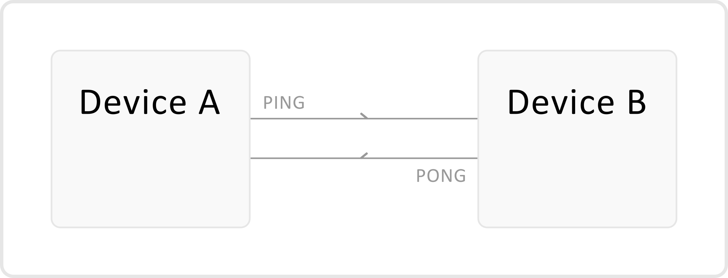

Open the Arduino IDE and create a new project. Name it **Lab03A_PingPong**.

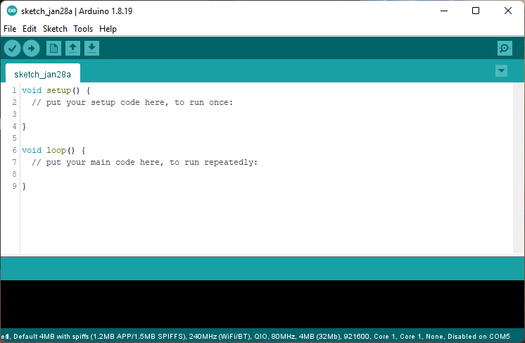

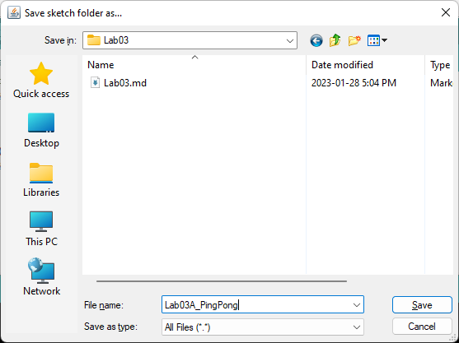

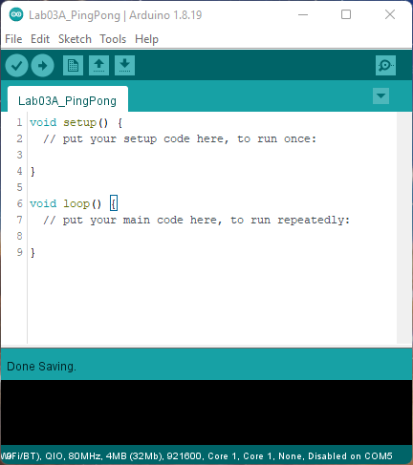

Create a header file to define and instantiate globally accessible data.

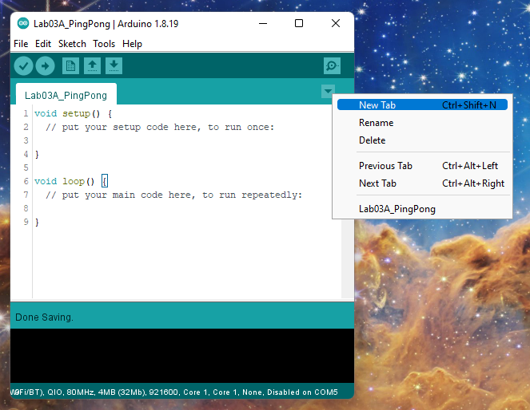

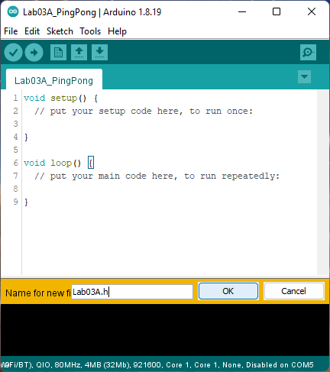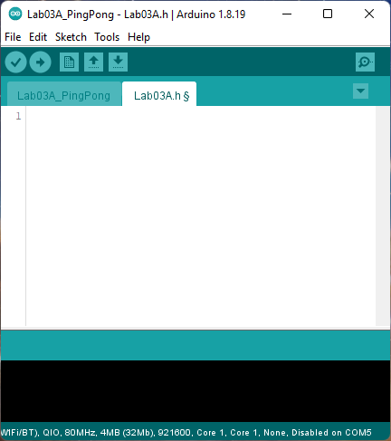

Include the following libraries and pin definitions.

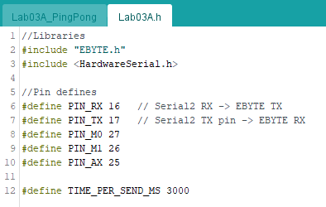

Create the following to tune the frequency band of your transceiver.

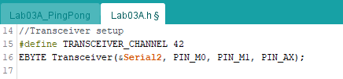

Set the device details to be unique for your group.

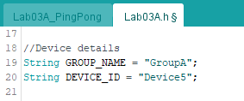

Navigate back to your implementation file.

Include your newly created header file.

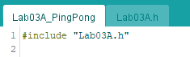

In the **setup()** file, initialize the serial monitor connected to your PC through UART, initialize the hardware serial 2 built-in to the ESP32 microcontroller. These must be set to 9600 baud for compatibility with the transceiver.

Using the Transceiver EBYTE transceiver object you are able to configure the settings of the transceiver through the 3 additional configuration pins. The library simplifies the process so you don’t need to submit AT configuration commands.

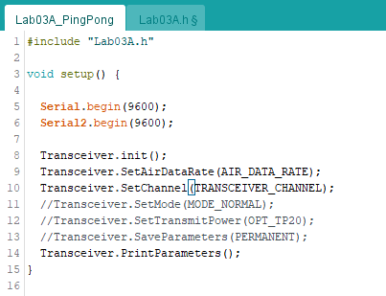

In the **loop()** function, there are two things that happen. First, the serial buffer is checked. If there is data being sent from the transceiver to the ESP32, it will read that string and print that to the serial monitor with **PING:**  in front of the data. If a specific amount of time elapses, it will periodically transmit data.

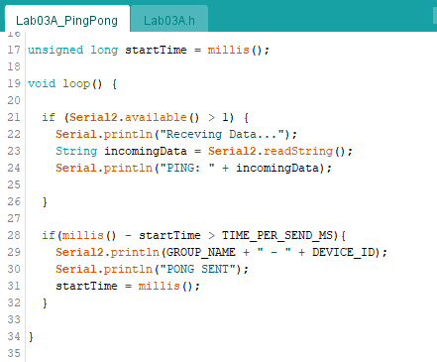

Make the device ID unique to your 1st microcontroller, select the COM port, and upload the sketch.

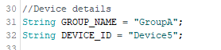

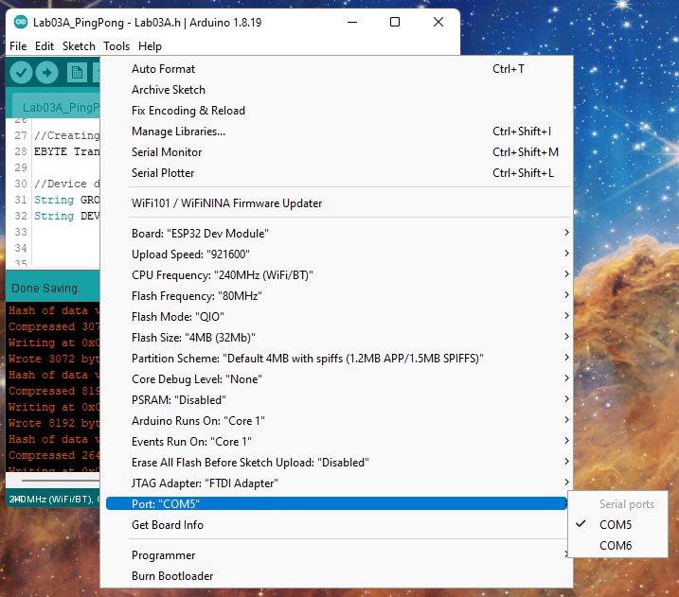

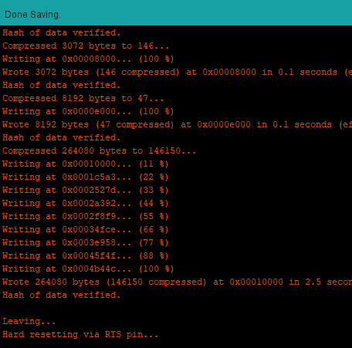

Modify the device ID to be unique to your 2nd microcontroller and upload the sketch to your 2nd ESP32. Also, change the COM port.

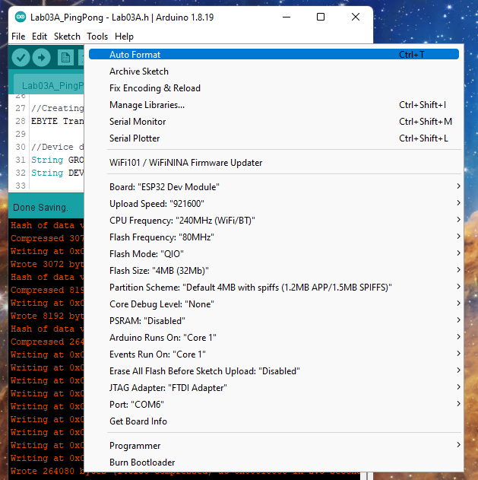

Open the 1st devices COM port and ensure that you are receiving the data that the 2nd device is transmitting.

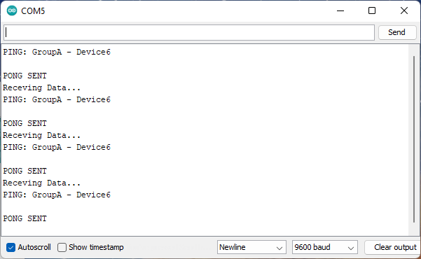

Open the 2nd devices COM port and ensure that you are receiving data being transmitted from the 1st devices transceiver.

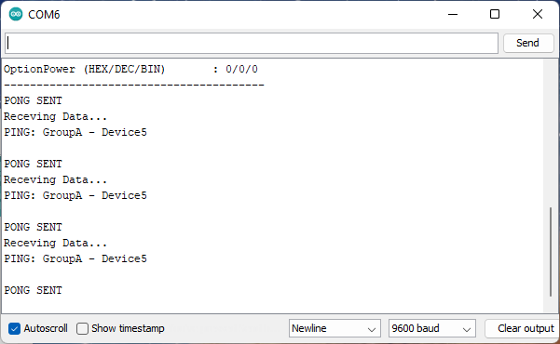

# Device Network

In this lab section, we will be developing a more sophisticated IoT network that involves 5 key components:

1. Field devices *(Sensors -> LoRa)*
2. Gateway devices *(LoRa -> WiFi)*
3. Server Back-end *(HTTP request routing)*
4. Dashboard Front-end *(Remote client access)*
5. Database connection *(Data collection and processing)*

The goal of building this IoT network is to demonstrate how different technologies and systems work together to build more robust and plausible networks.

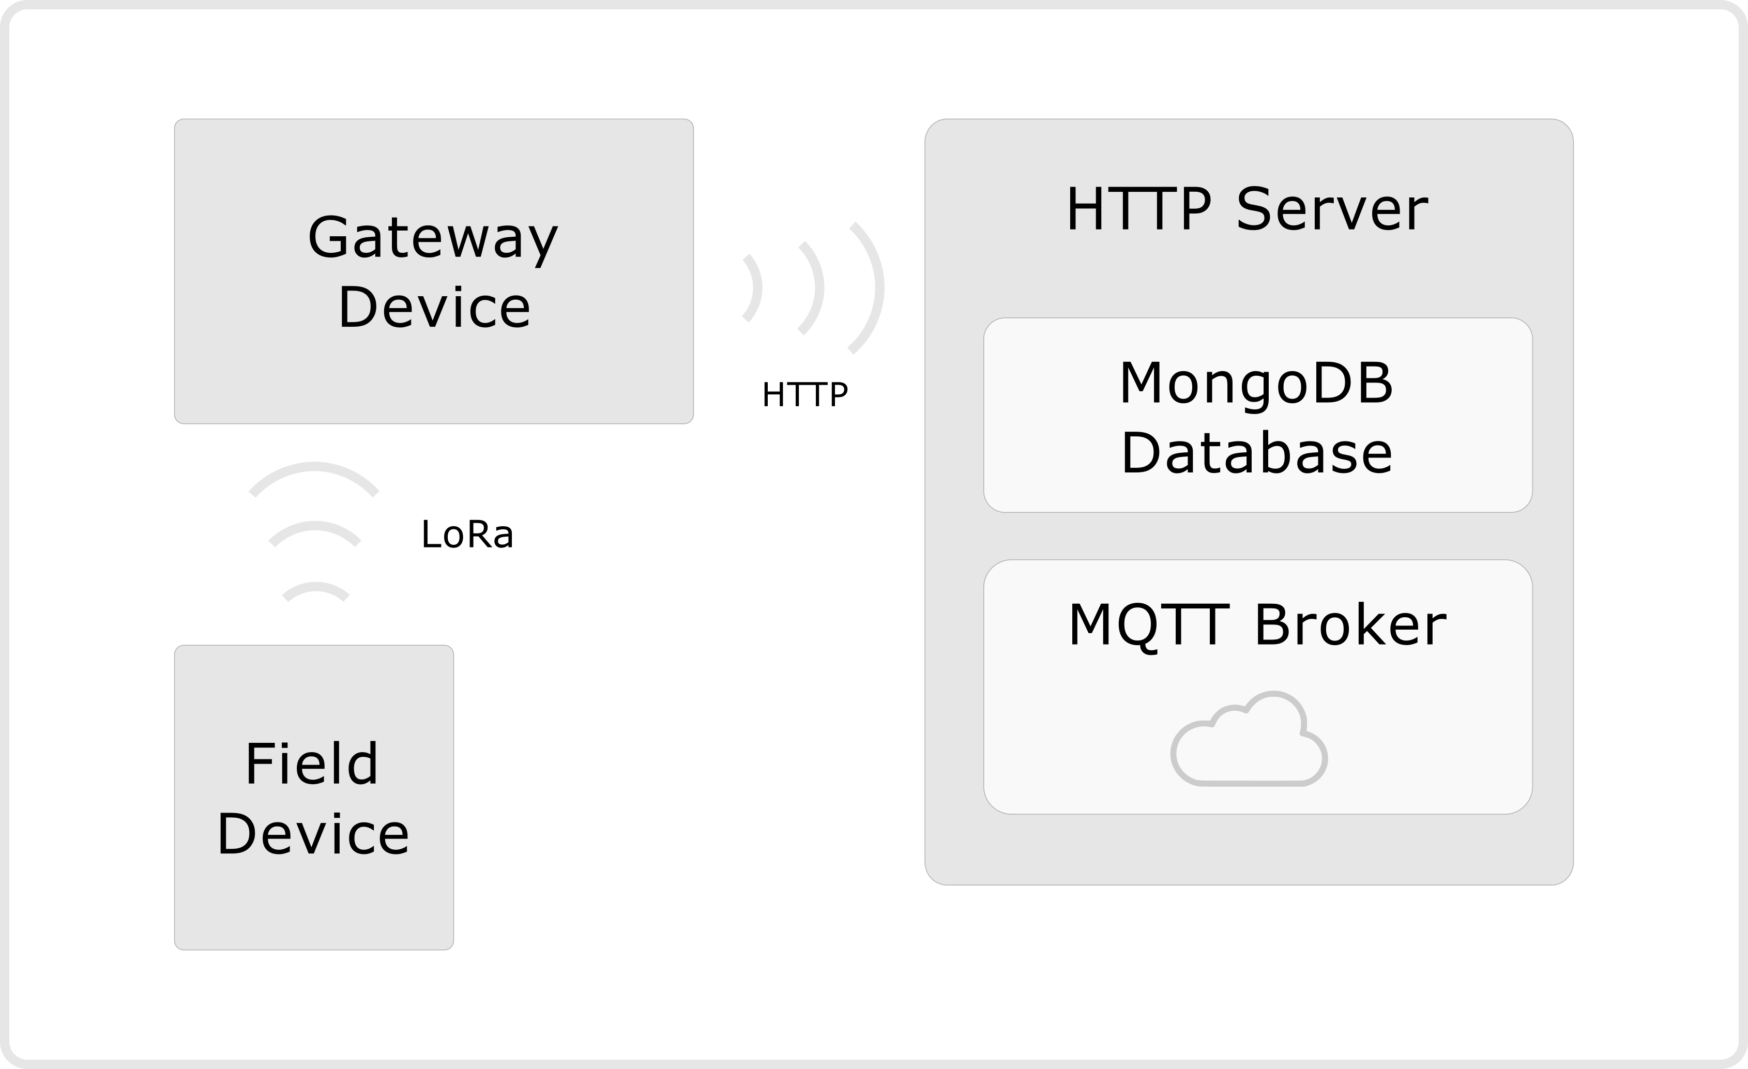

Navigate to your **4ID3/Lab03** repository and create a folder called **Lab03B**.

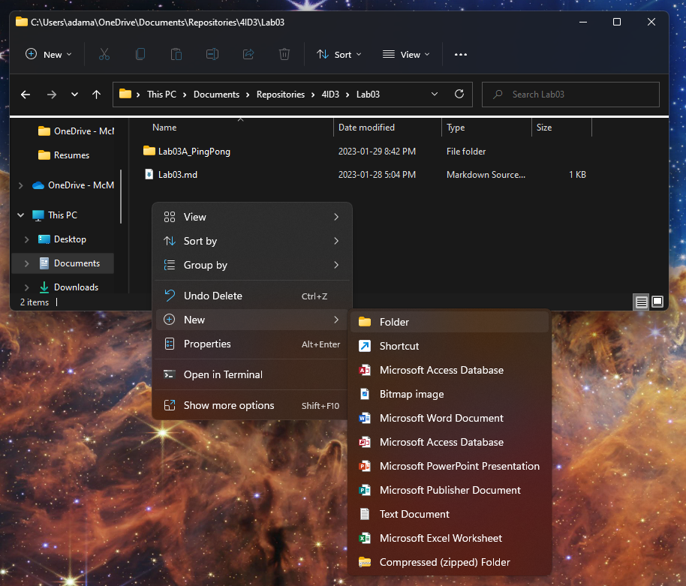 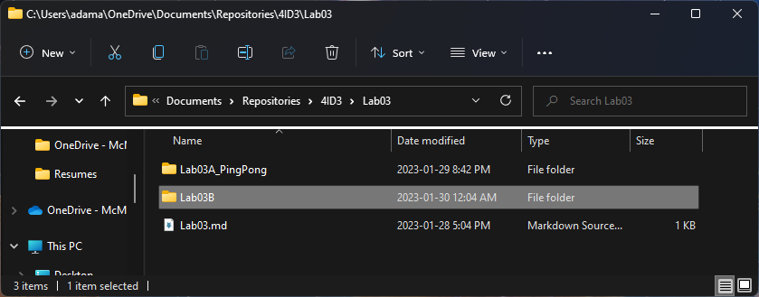

## Field Device

The role of the device is to collect data from sensors and transmit that data over longer distances to a central device that has many field devices connected to it. The field device will be built similar to the previous lab section.

Open the Arduino IDE and create a new sketch. Name it **FieldDevice** and save it in the **Lab03/Lab03B** folder.

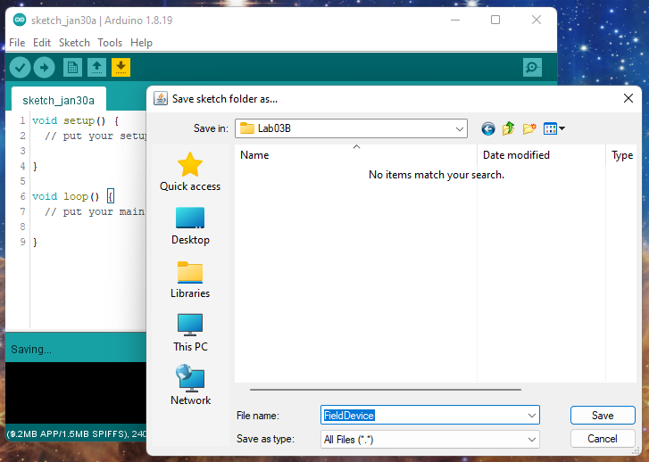

Next, create a header file to store constants, singleton classes, and configuration variables.

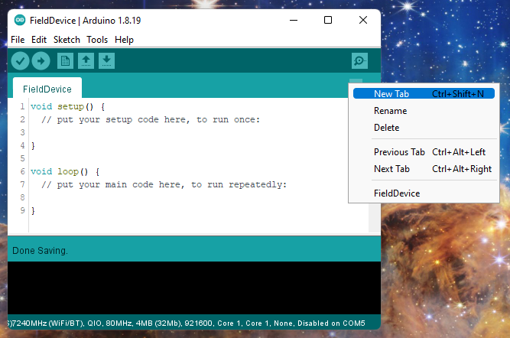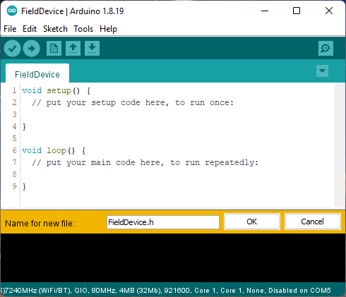

Firstly, in the header file, include the following libraries:

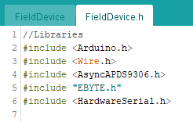

Next, define your pin data.

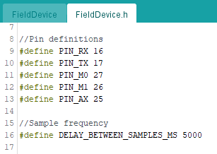

Next, configure your LoRa object.

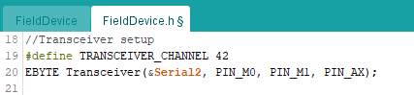

Set up your device information.

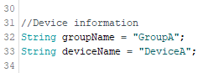

Set up your sensors.

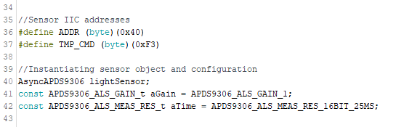

Next, include this header file in your implementation file.

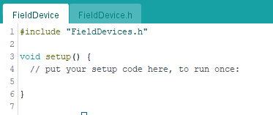

In the **setup()** function, initialize your transceiver.

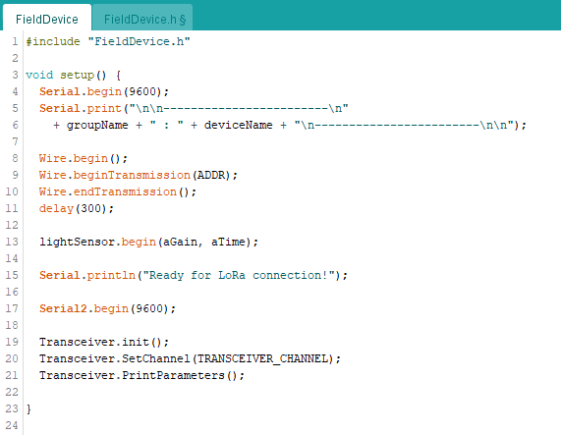

In the **loop()** function, sample the sensors periodically, aggregate the data into a JSON message, and transmit that message over LoRa.

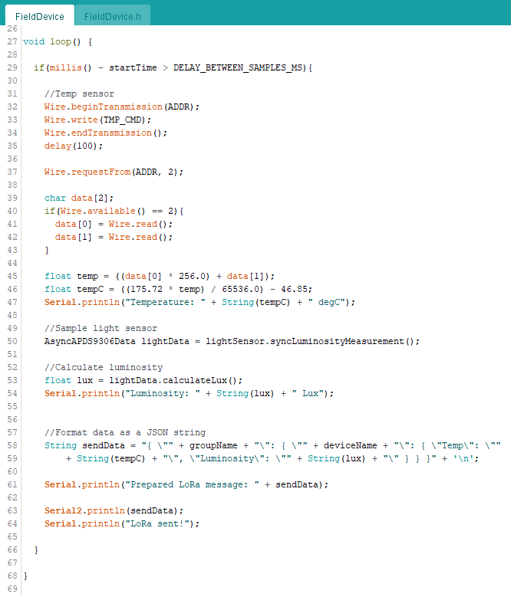

## Gateway Device

The role of the gateway device is to receive data from multiple field devices and transmit them to a server that can further process the data.

Start off by creating a new sketch and naming it **GatewayDevice**. Save it in the **4ID3/Lab03** folder.

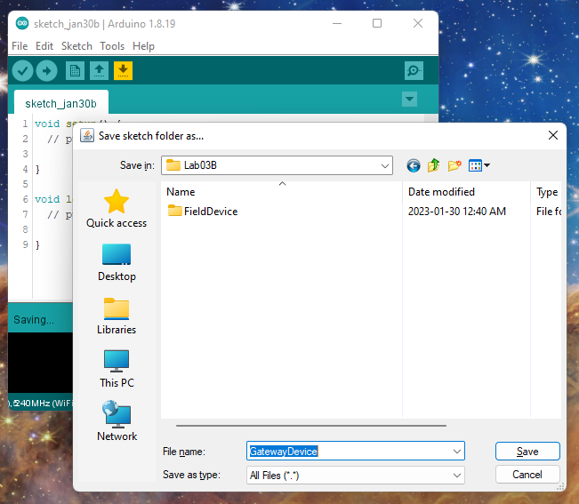

Next, create a header file to include any global variables or objects.

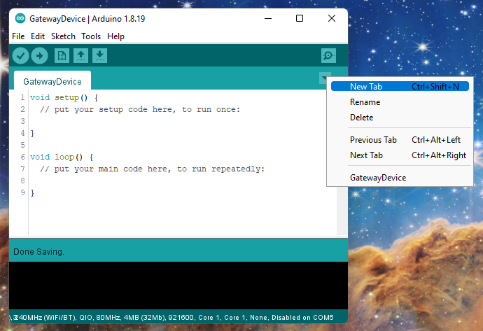

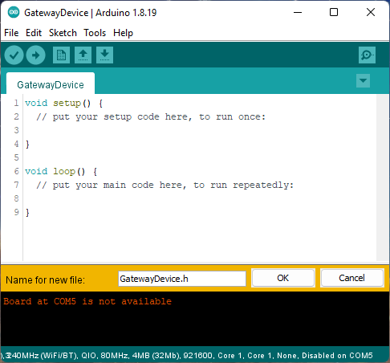 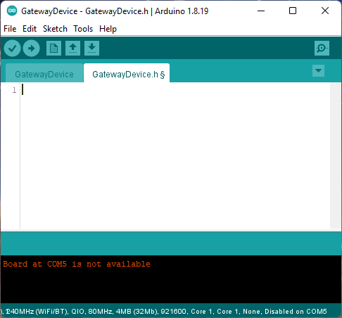

Set up the header file like this:

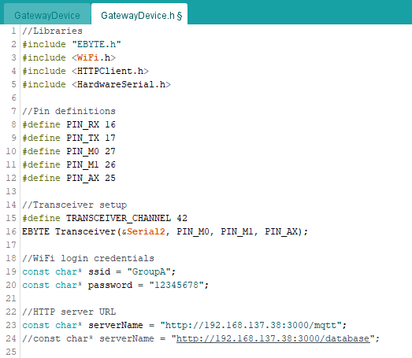

Next, in the implementation file, we want to poll if the LoRa serial receive buffer has data in it. If so, read that data and make a POST request to the server.

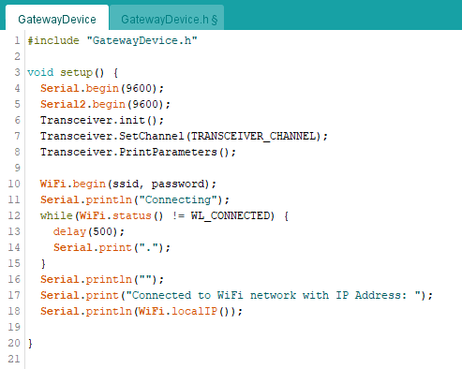

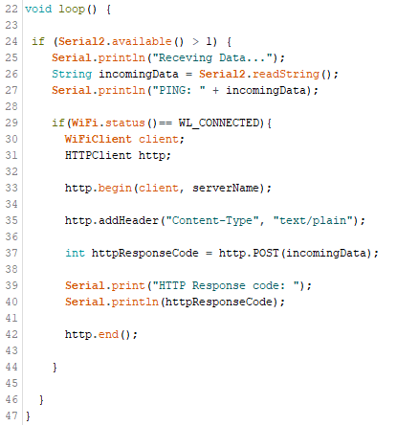

## HTTP Server

The role of the HTTP server is to route the data that is being sent by the gateway to a set a pre-defined callback functions called **routes**.

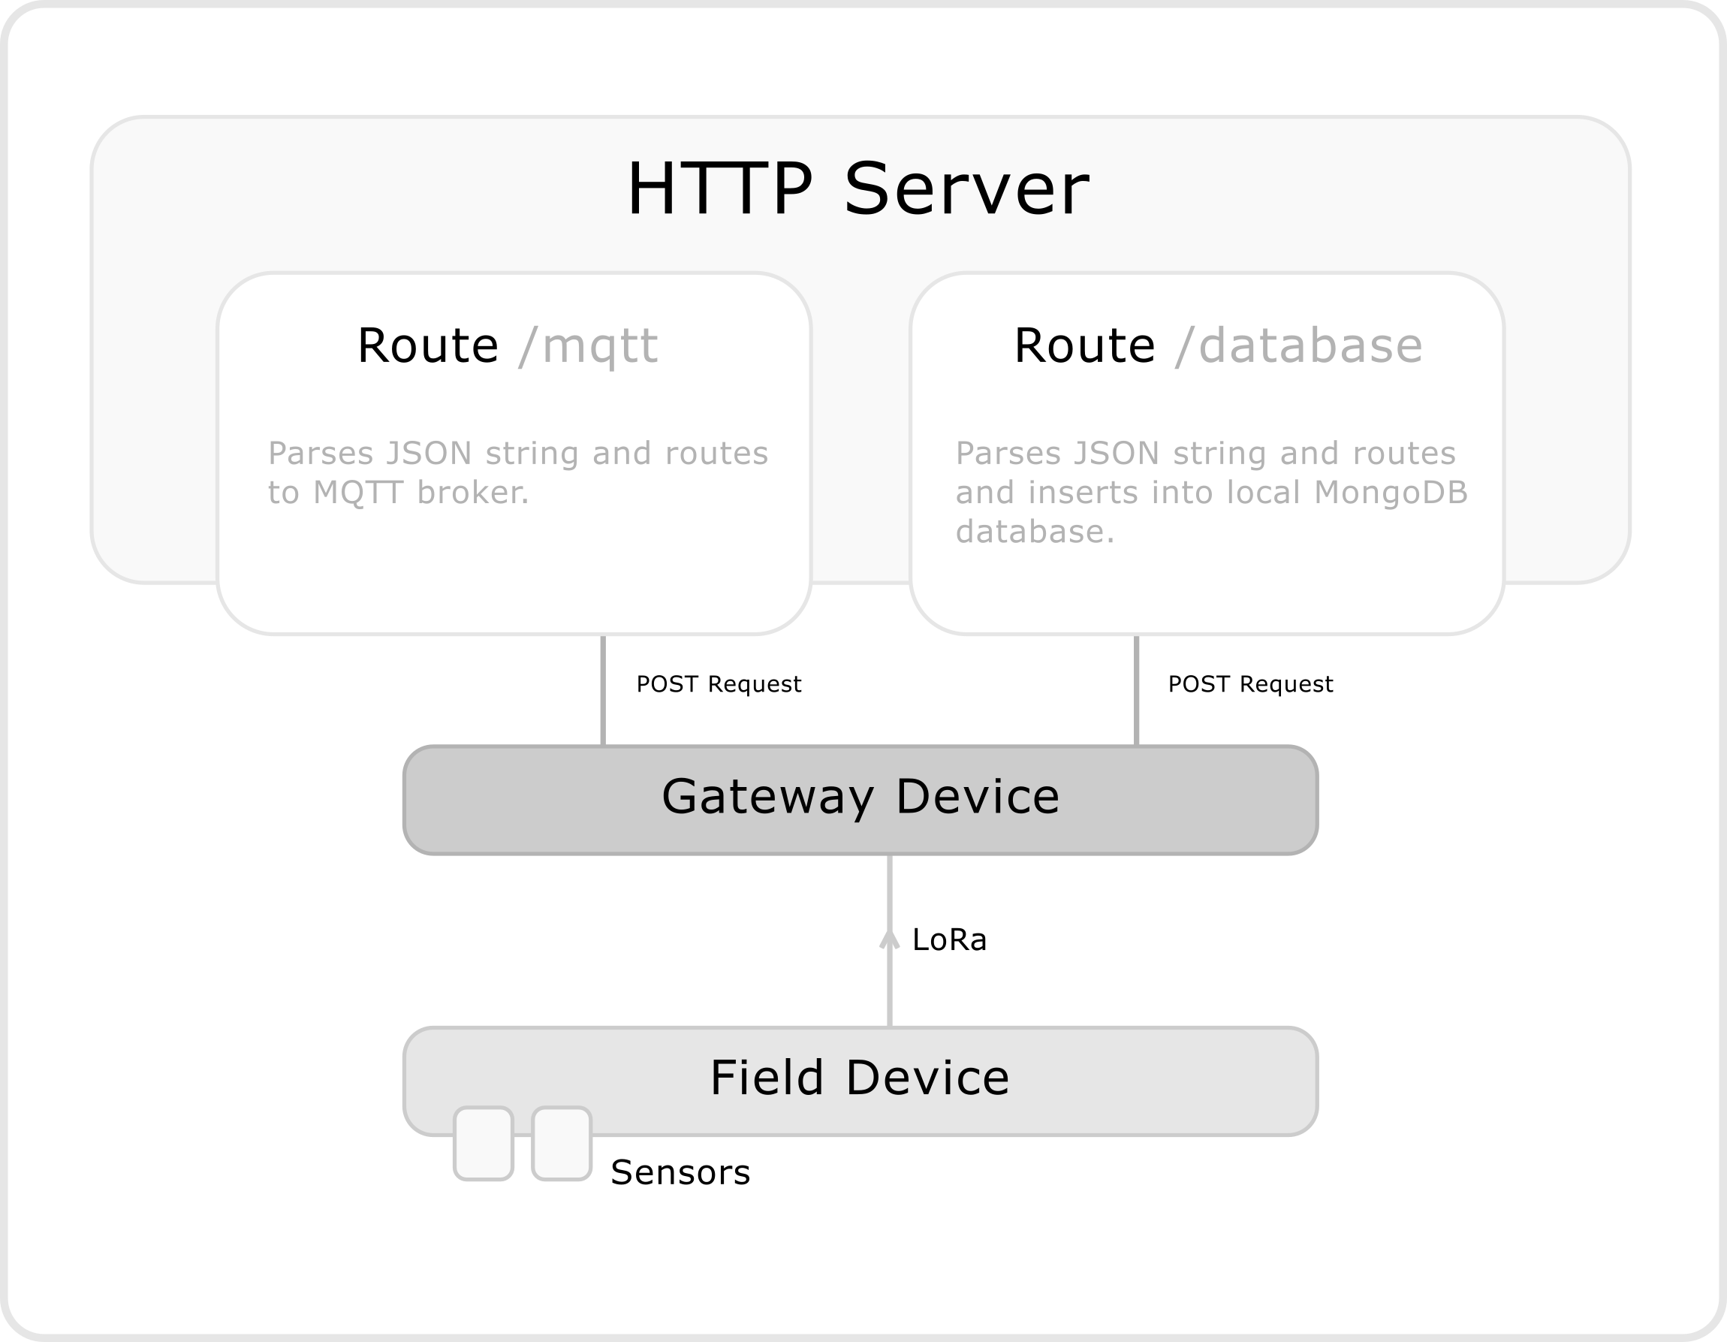

### Repo Setup

Open **VSCode** and open your local repository in the project viewer.

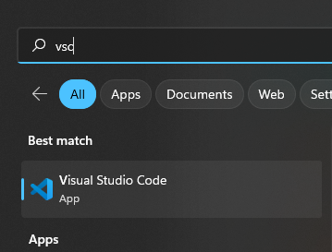

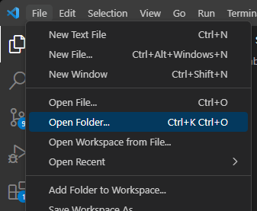

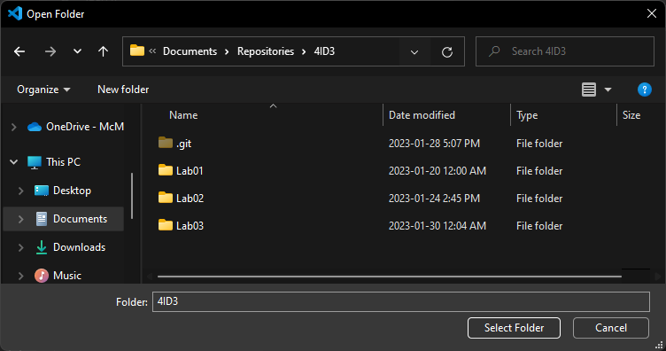

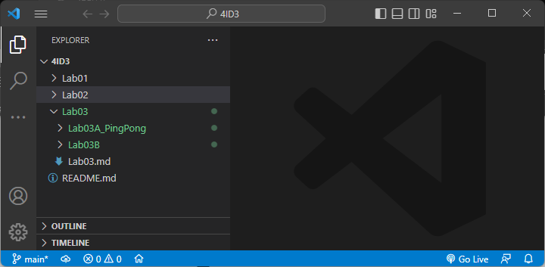

Create a new folder in the **4ID3/Lab03/Lab03B** directory called **HTTPServer.py**.

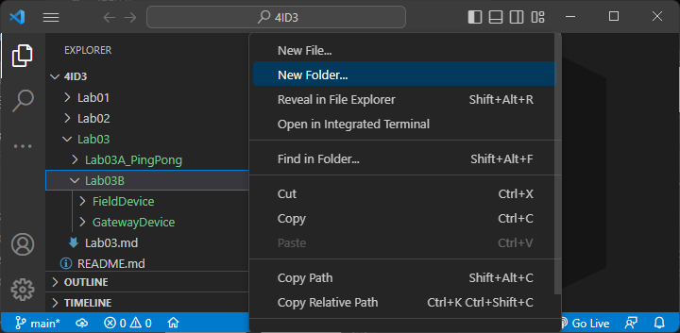

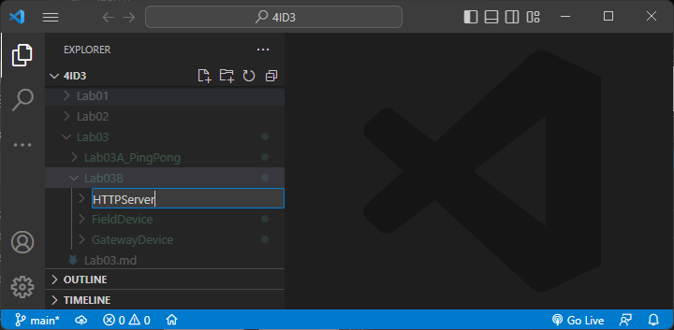

Create a new **python script** in this directory called **HTTPServer.py**.

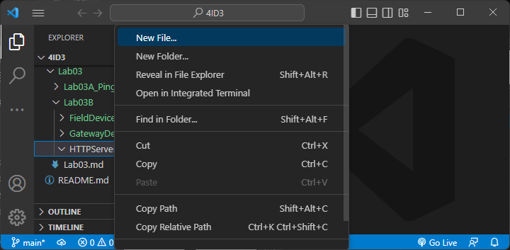

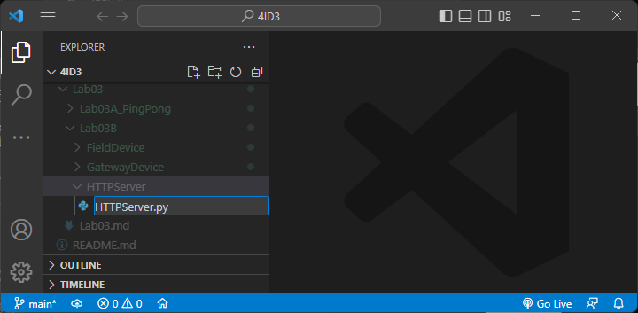

### Python Libraries

Install the following libraries using the **pip** package manager using **PowerShell**, running as **Administrator**.

*pip install pymongo*

*pip install paho-mqtt*

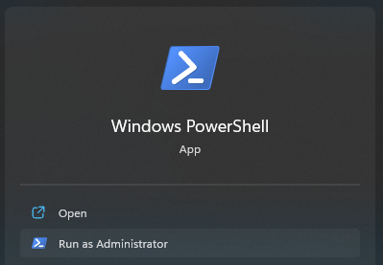

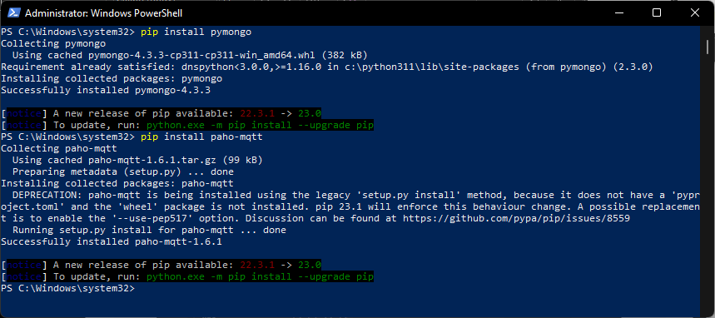

### IoT Server Overview

Return to the empty python script and begin by importing libraries and creating variables to store constant information.

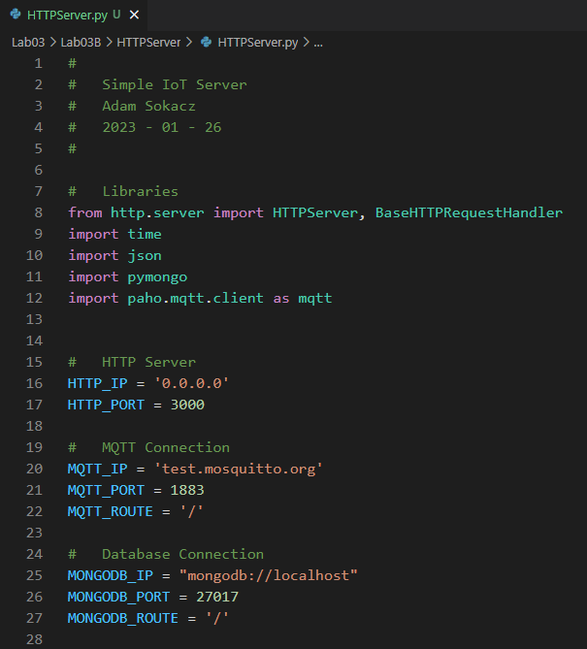

Set up your main function as such:

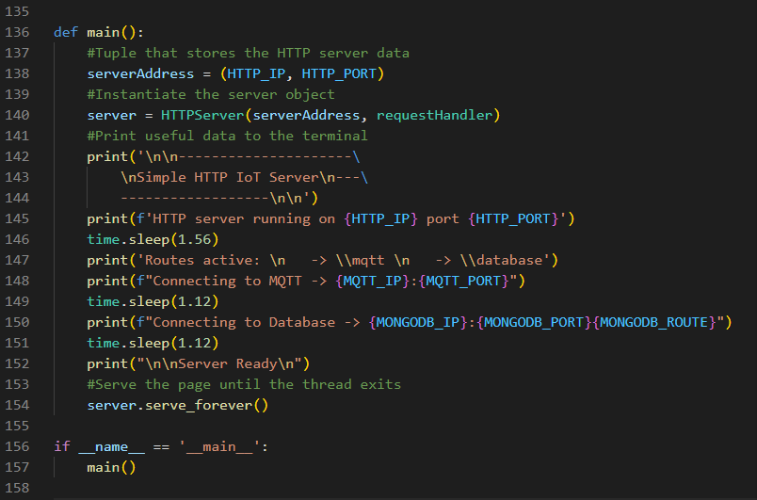

Notice that the HTTP server requires a callback function to be passed into it on object creation. This function handles what to do when a device or computer connects to the server. It should be implemented above.

First, implement the GET requests. There are only a couple here for testing and to view the most recent data.

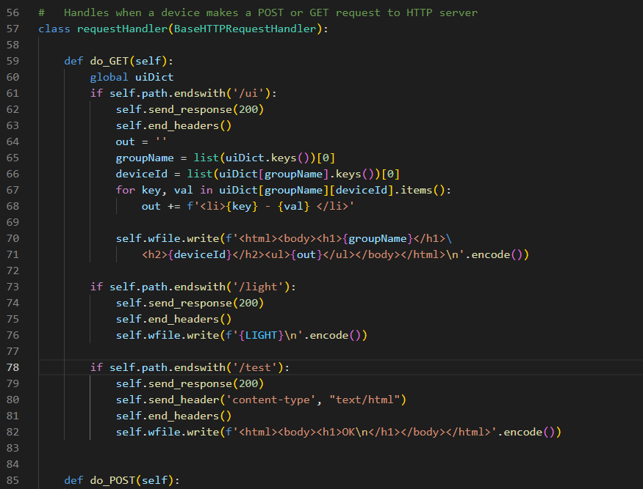

Next, set up the **/database route**, which looks at the payload, restructures it, and inserts it into the local database on your system.

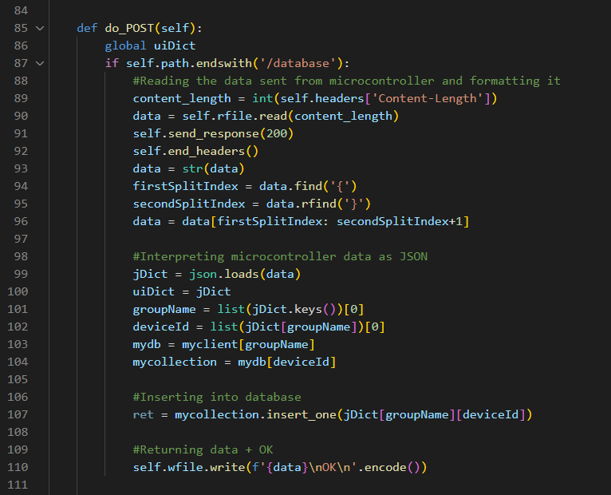

Next, set up the **/mqtt** **route**, which looks at the payload, restructures it, then publishes it to its corresponding MQTT path.

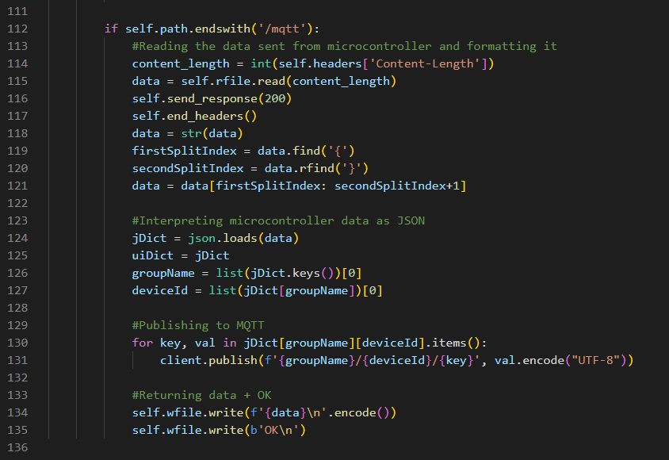

Lastly, set up the MQTT and MongoDB objects earlier in the script.

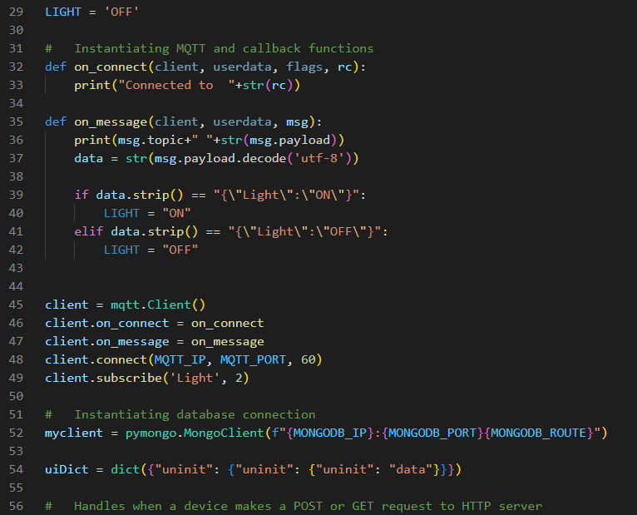

Full code:

*#*

*# Simple IoT Server*

*# Adam Sokacz*

*# 2023 - 01 - 26*

*#*

*# Libraries*

*from http.server import HTTPServer, BaseHTTPRequestHandler*

*import time*

*import json*

*import pymongo*

*import paho.mqtt.client as mqtt*

*# HTTP Server*

*HTTP_IP = '0.0.0.0'*

*HTTP_PORT = 3000*

*# MQTT Connection*

*MQTT_IP = 'test.mosquitto.org'*

*MQTT_PORT = 1883*

*MQTT_ROUTE = '/'*

*# Database Connection*

*MONGODB_IP = "mongodb://localhost"*

*MONGODB_PORT = 27017*

*MONGODB_ROUTE = '/'*

*LIGHT = 'OFF'*

*# Instantiating MQTT and callback functions*

*def on_connect(client, userdata, flags, rc):*

*print("Connected to "+str(rc))*

*def on_message(client, userdata, msg):*

*print(msg.topic+" "+str(msg.payload))*

*data = str(msg.payload.decode('utf-8'))*

*if data.strip() == "{\"Light\":\"ON\"}":*

*LIGHT = "ON"*

*elif data.strip() == "{\"Light\":\"OFF\"}":*

*LIGHT = "OFF"*

*client = mqtt.Client()*

*client.on_connect = on_connect*

*client.on_message = on_message*

*client.connect(MQTT_IP, MQTT_PORT, 60)*

*client.subscribe('Light', 2)*

*# Instantiating database connection*

*myclient = pymongo.MongoClient(f"{MONGODB_IP}:{MONGODB_PORT}{MONGODB_ROUTE}")*

*uiDict = dict({"uninit": {"uninit": {"uninit": "data"}}})*

*# Handles when a device makes a POST or GET request to HTTP server*

*class requestHandler(BaseHTTPRequestHandler):*

*def do_GET(self):*

*global uiDict*

*if self.path.endswith('/ui'):*

*self.send_response(200)*

*self.end_headers()*

*out = ''*

*groupName = list(uiDict.keys())[0]*

*deviceId = list(uiDict[groupName].keys())[0]*

*for key, val in uiDict[groupName][deviceId].items():*

*out += f'<li>{key} - {val} </li>'*

*self.wfile.write(f'<html><body><h1>{groupName}</h1>*

*<h2>{deviceId}</h2><ul>{out}</ul></body></html>\n'.encode())*

*if self.path.endswith('/light'):*

*self.send_response(200)*

*self.end_headers()*

*self.wfile.write(f'{LIGHT}\n'.encode())*

*if self.path.endswith('/test'):*

*self.send_response(200)*

*self.send_header('content-type', "text/html")*

*self.end_headers()*

*self.wfile.write(f'<html><body><h1>OK\n</h1></body></html>'.encode())*

*def do_POST(self):*

*global uiDict*

*if self.path.endswith('/database'):*

*#Reading the data sent from microcontroller and formatting it*

*content_length = int(self.headers['Content-Length'])*

*data = self.rfile.read(content_length)*

*self.send_response(200)*

*self.end_headers()*

*data = str(data)*

*firstSplitIndex = data.find('{')*

*secondSplitIndex = data.rfind('}')*

*data = data[firstSplitIndex: secondSplitIndex+1]*

*#Interpreting microcontroller data as JSON*

*jDict = json.loads(data)*

*uiDict = jDict*

*groupName = list(jDict.keys())[0]*

*deviceId = list(jDict[groupName])[0]*

*mydb = myclient[groupName]*

*mycollection = mydb[deviceId]*

*#Inserting into database*

*ret = mycollection.insert_one(jDict[groupName][deviceId])*

*#Returning data + OK*

*self.wfile.write(f'{data}\nOK\n'.encode())*

*if self.path.endswith('/mqtt'):*

*#Reading the data sent from microcontroller and formatting it*

*content_length = int(self.headers['Content-Length'])*

*data = self.rfile.read(content_length)*

*self.send_response(200)*

*self.end_headers()*

*data = str(data)*

*firstSplitIndex = data.find('{')*

*secondSplitIndex = data.rfind('}')*

*data = data[firstSplitIndex: secondSplitIndex+1]*

*#Interpreting microcontroller data as JSON*

*jDict = json.loads(data)*

*uiDict = jDict*

*groupName = list(jDict.keys())[0]*

*deviceId = list(jDict[groupName])[0]*

*#Publishing to MQTT*

*for key, val in jDict[groupName][deviceId].items():*

*client.publish(f'{groupName}/{deviceId}/{key}', val.encode("UTF-8"))*

*#Returning data + OK*

*self.wfile.write(f'{data}\n'.encode())*

*self.wfile.write(b'OK\n')*

*def main():*

*#Tuple that stores the HTTP server data*

*serverAddress = (HTTP_IP, HTTP_PORT)*

*#Instantiate the server object*

*server = HTTPServer(serverAddress, requestHandler)*

*#Print useful data to the terminal*

*print('\n\n---------------------*

*\nSimple HTTP IoT Server\n---*

*------------------\n\n')*

*print(f'HTTP server running on {HTTP_IP} port {HTTP_PORT}')*

*time.sleep(1.56)*

*print('Routes active: \n -> \\mqtt \n -> \\database')*

*print(f"Connecting to MQTT -> {MQTT_IP}:{MQTT_PORT}")*

*time.sleep(1.12)*

*print(f"Connecting to Database -> {MONGODB_IP}:{MONGODB_PORT}{MONGODB_ROUTE}")*

*time.sleep(1.12)*

*print("\n\nServer Ready\n")*

*#Serve the page until the thread exits*

*server.serve_forever()*

*if __name__ == '__main__':*

*main()*

## Setting up the IoT Network

Connection Overview:

**PC 1** powers **Field Device** and **Gateway Device** over **USB**.

**PC 1** performs a **mobile hotspot.**

**PC 2 connects** to the **mobile hotspot** and then runs the **webserver**.

**PC 2**  tries to access **<server_pc_ip_address>:3000/test**

**Mobile Device** **connects** to **mobile hotspot** and tries to access **<server_pc_ip_address>:3000/test**

Once the mobile device has proved that the server is accessible, disconnect it from the network.

Have a **groupmate** use their computer to start a **Windows Mobile Hotspot**.

Add the login credentials to this hotspot into the **GatewayDevice** configuration and **upload** that to the MacIoT board.

**Upload** the **FieldDevice** sketch to the other MacIoT board.

Connect your PC (*The PC running the HTTP server*) to the **same Mobile Hotspot** network.

In my case, the **IP address** for my **server PC** is *192.168.137.38*.

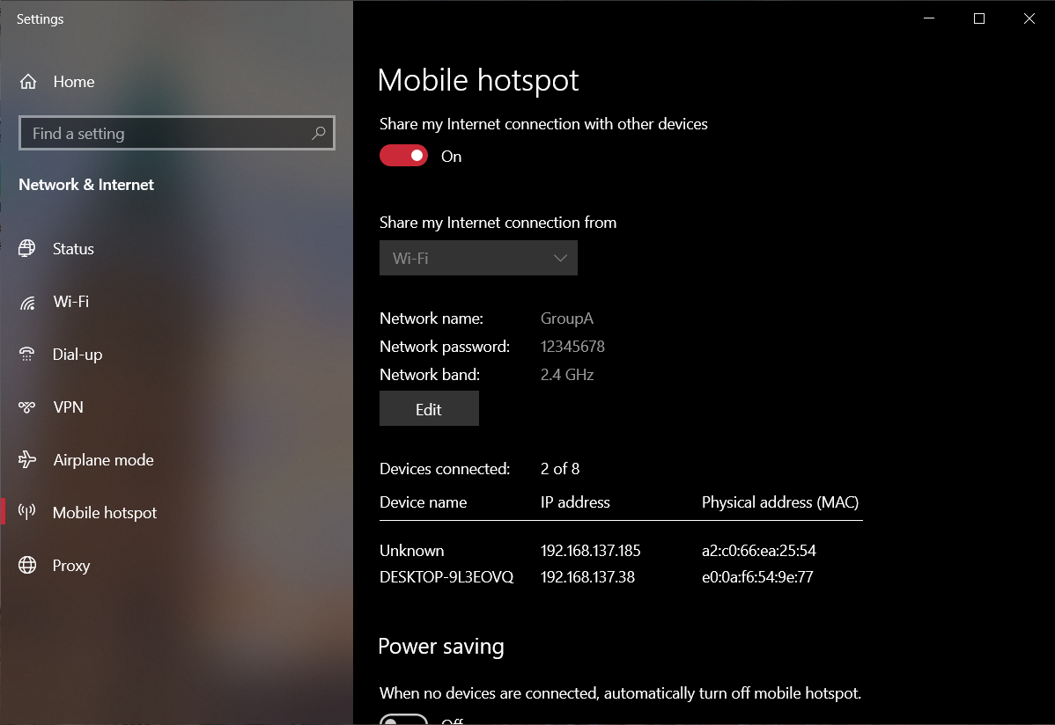

Next, launch the python script.

*python HTTPServer.py*

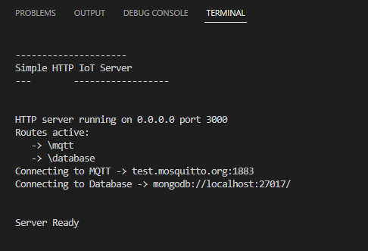

In a web browser on your **server PC**, search the following URL:

*localhost:3000/test*

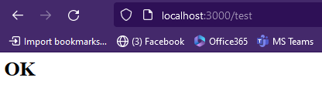

You should receive **OK** without any hassles.

Using either a **mobile phone** or third PC, connect to your group’s mobile hotspot.

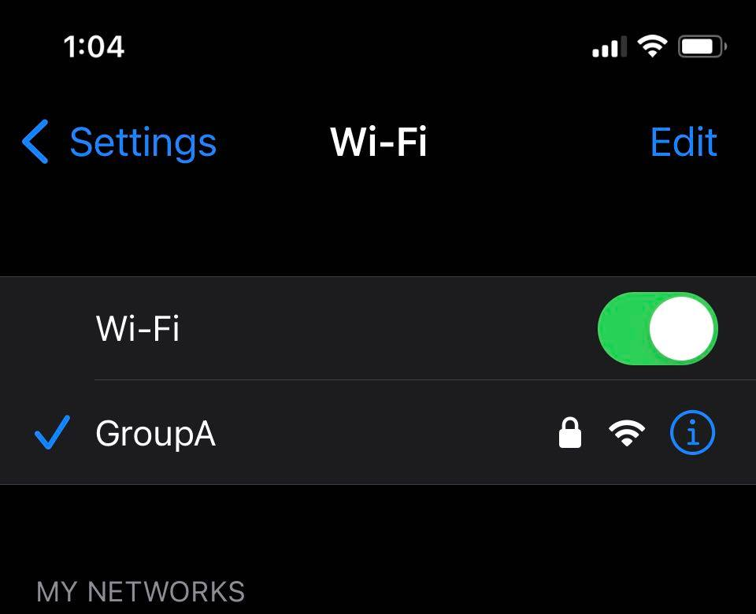

Type the IP address and path of your server URL and test route into a web browser on your mobile phone.

In my case, this would be: *192.168.137.38:3000/test*.

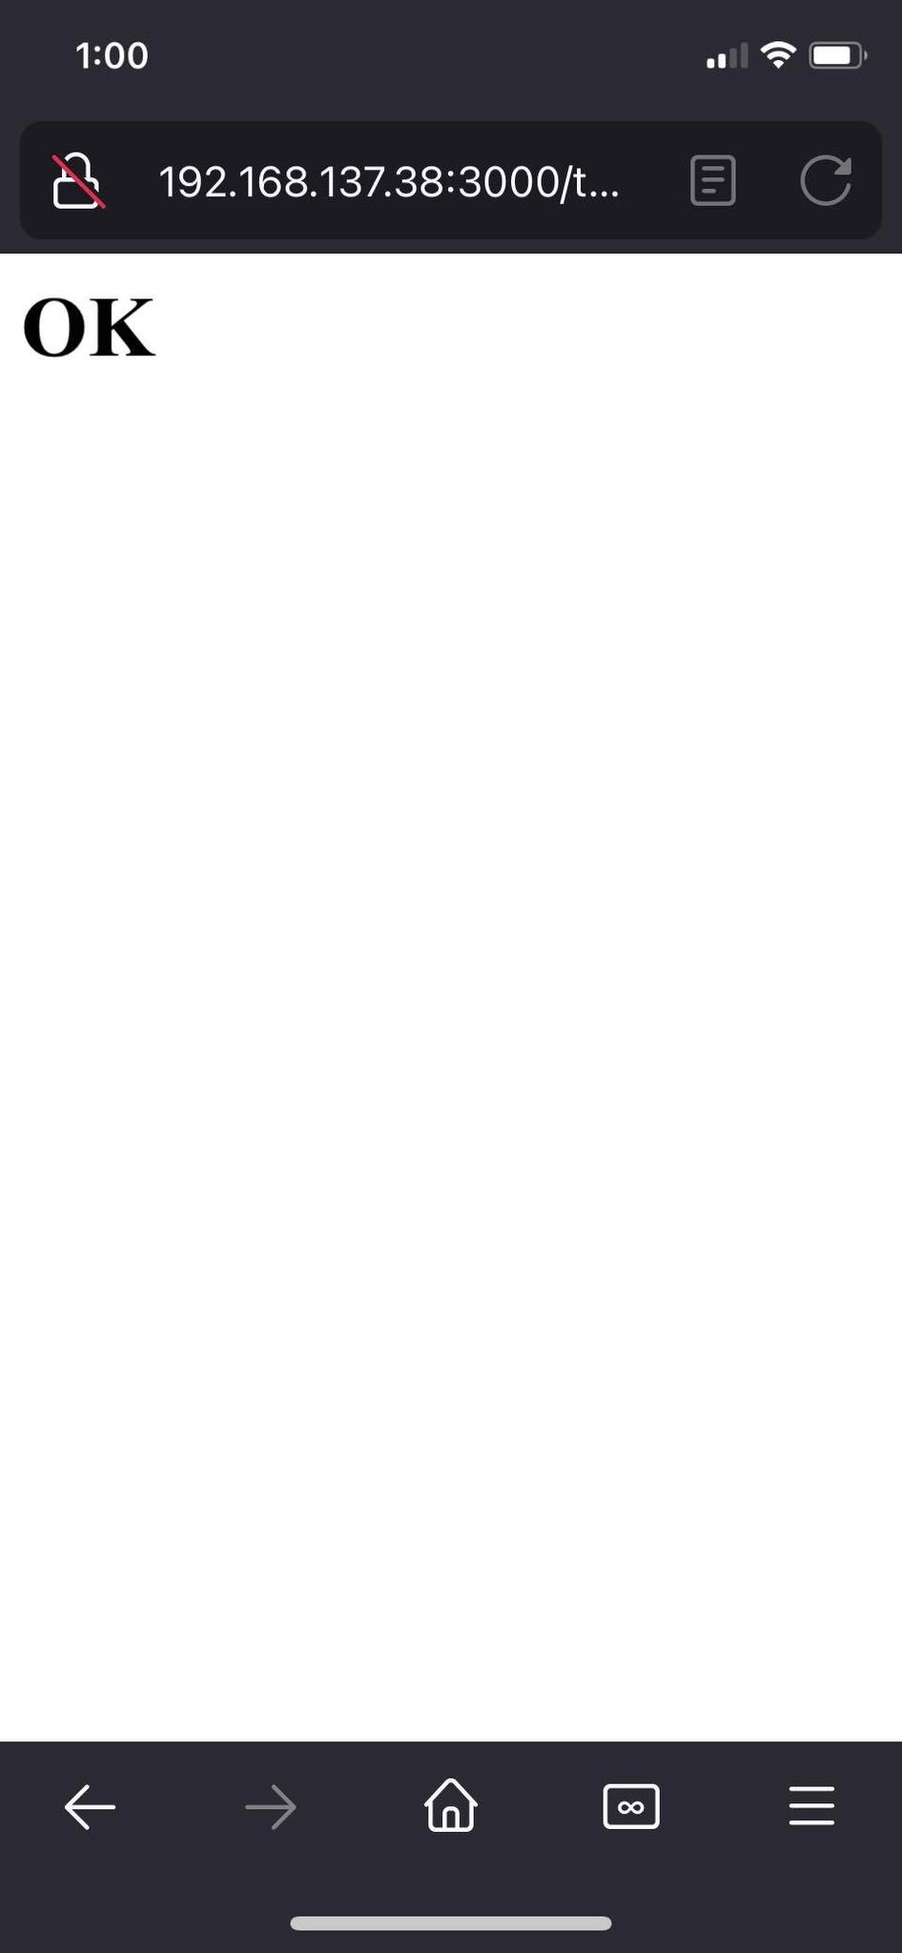

The reason why we require a third device, is that the PC running the mobile hotspot cannot connect to any servers on its network for security reasons.

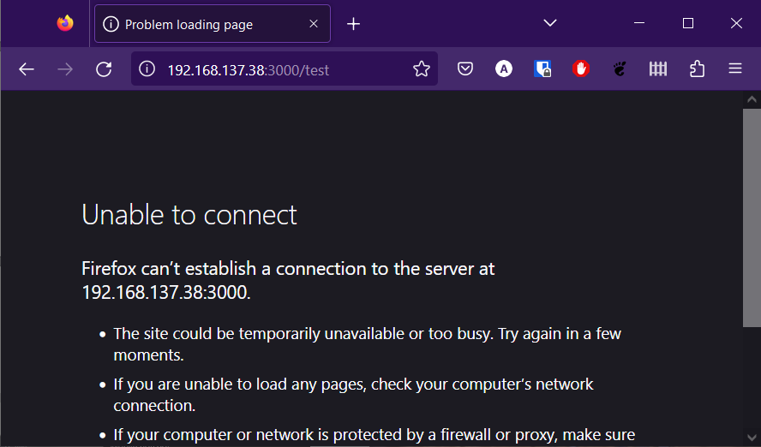

## Integrating Everything Together

Now that each component of this IoT network is created, **upload** your **FieldDevice** and **GatewayDevice sketches** to two different MacIoT boards.

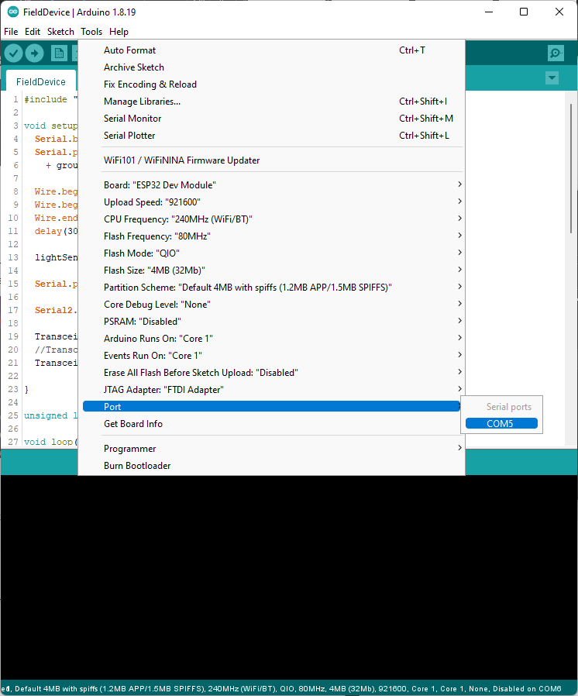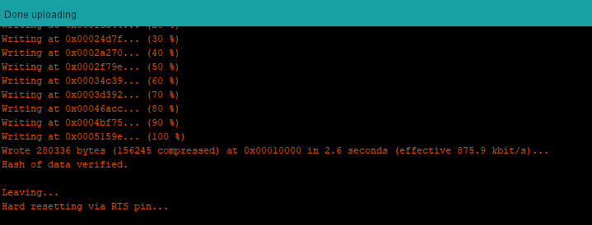

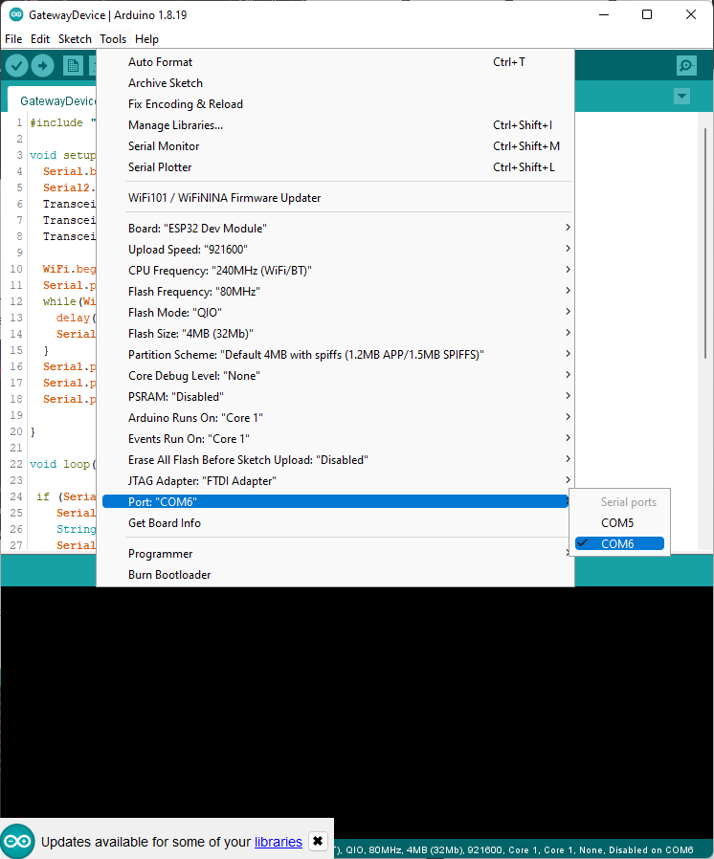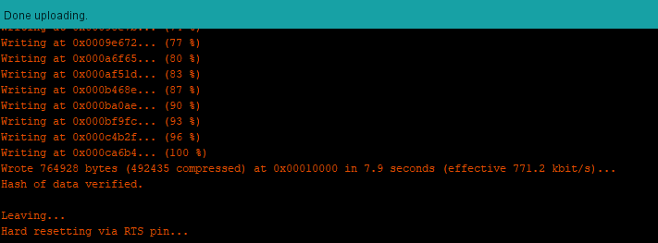

Watch the mobile hotspot PC and confirm that the **GatewayDevice** has connected successfully.

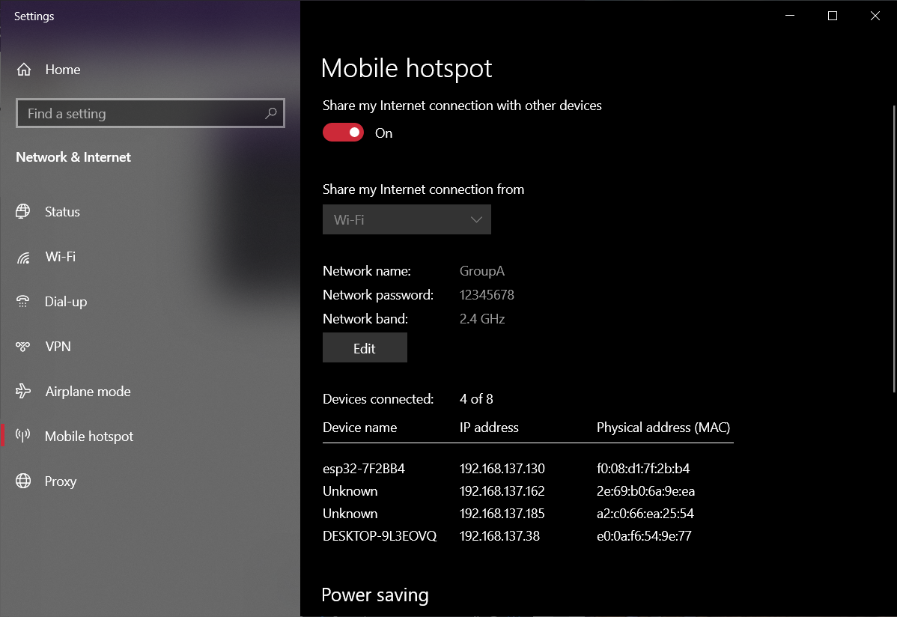

View each COM port and ensure that they are communicating through LoRa.

Field Device:

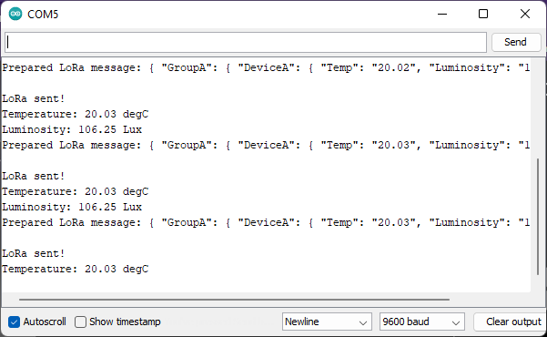

Gateway Device:

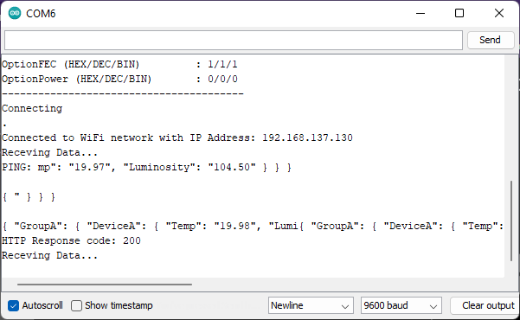

In the **server** script, you should see data printing.

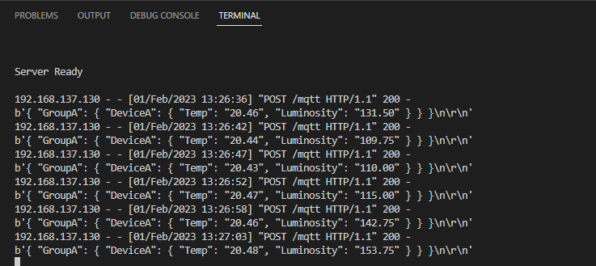

In your browser, navigate to: **ip_address:port/ui** to see the most recent parsed data.

# Exercise A

Using a mobile phone, connect and view the data being published. Submit a screenshot with your report.

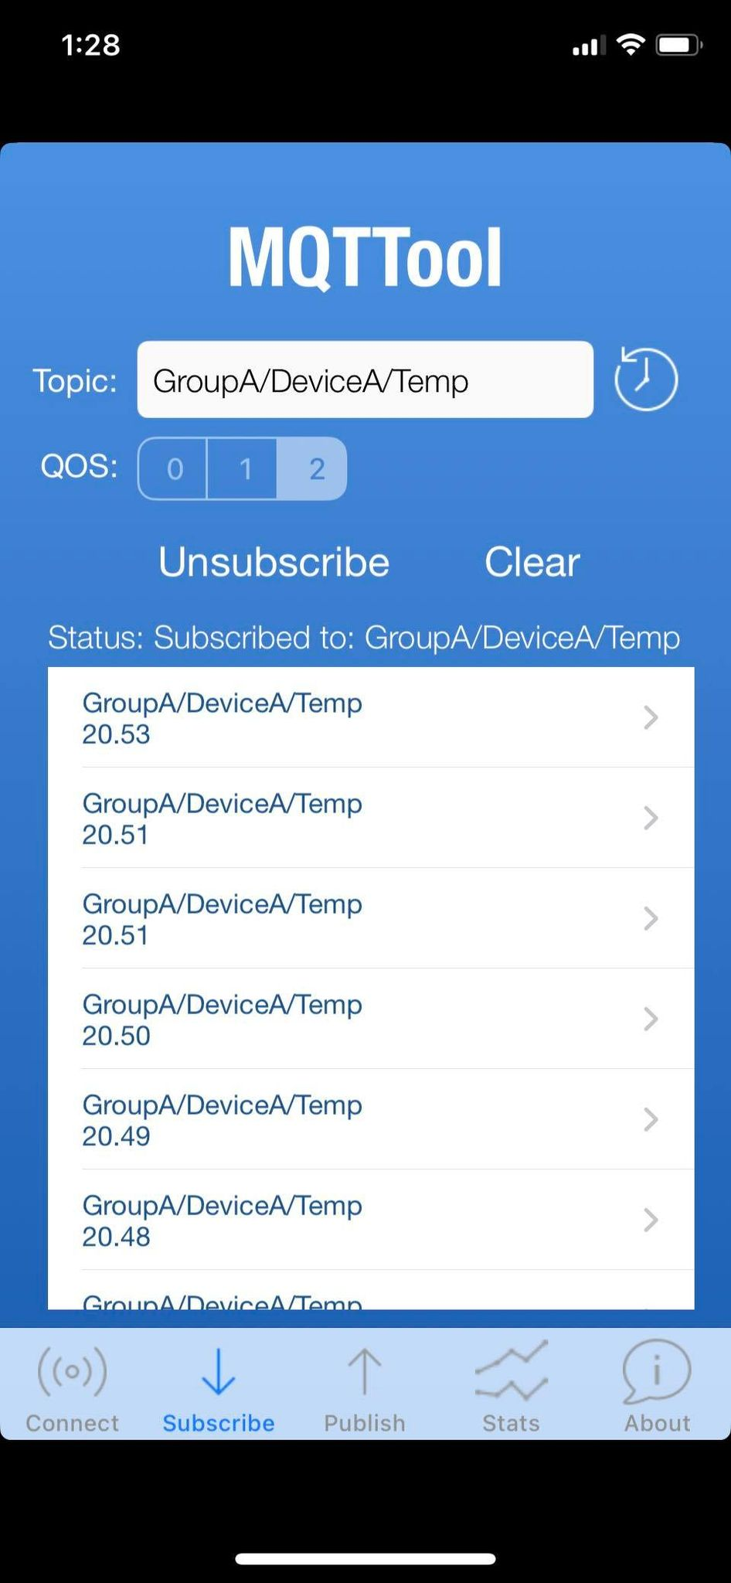

# Exercise B

Create a NodeRED flow to visualize the data being published to **test.mosquitto.org**. Submit a screenshot with your report.

# Exercise C

Modify the **URL** on the **Gateway Device** to make HTTP requests to the database API instead of the MQTT API.

<server_ip>:3000/database

The setting can be found here:

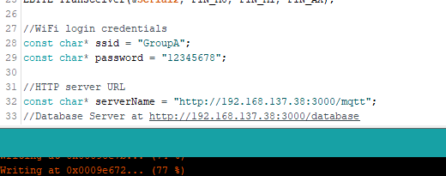

View the data being added to your local database. Save a screenshot of the MongoDB Compass database viewer.

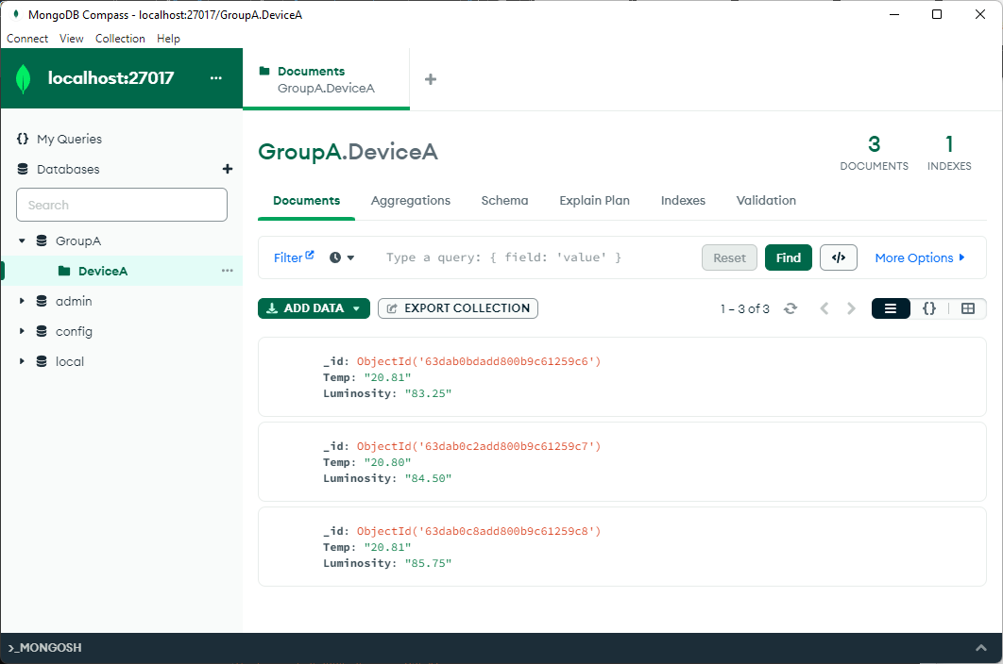

Plot this data in excel. Include a chart with your report.

|  |
| --- |
| END |